Our Journeys, Our Stories, Our Delaware
June 8th Community Festival at Greenwood

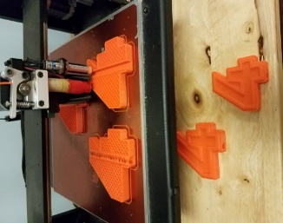
(Trophies made by Bridgeville Library)



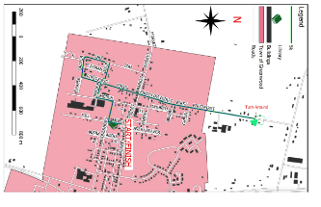
(GPS Map by Colton Phillips)

Sponsored by The Riff, Woodbridge High’s Student Literary Art Magazine,
MCJROTC, The Greenwood VFW, The Greenwood Public Library, and WHS NHS. Please see the back of this program to thank our sponsors from all directions in Delaware.
When you think of art, many go straight to the canvas or museum in thought. From the origins of a literary art magazine that delves into redefining what art is through the community, a new venture known as The Riff, Woodbridge High’s new emerging student literary art magazine, a new definition of art emerges.

We hope you enjoy the art of community today, we would like to share photographs, stories, paintings, sketches, and more with us as we develop our first literary art magazine. We want you to provide us feedback on how to develop this first annual community festival further to show who we are as a community when support is needed.

As the state of Delaware has rallied behind Troy Haynes this year, we see what Delawareans are made up of when the call is made. We want to continue a tradition, as a student literary art magazine, to work with the community and seek out what defines art in the form of a community. Kudos to Regan Todd who created the theme and phrase, Our Journeys, Our Stories, Our Delaware, as we each find our own story. No activities or support would be possible without the collective efforts of those listed on the back of this program, as well as you, our attendee.

Enjoy the day and please provide feedback on contributing to our magazine, supporting art in our community, and what we can do even more to show off our community possibilities.
harry.brake@wsd.k12.de.us

The Riff Student Literary Art Magazine
https://therifflitmag.tumblr.com/ 

7:00 – 7:45 AM Preregistration for 5k
Audio by Slim Street Sounds
Pre-registered individuals report to Amity at 13 Market Street for their shirts, numbers, and water bottle.
On-site registering individuals report to the Greenwood Public Library parking lot for registration, number, and shirts.

8:00 AM Start of 5k to 10:00 AM- Finish of 5k

11:00 AM Start of Community Festival
VFW Building – Gaming Activities
Greenwood Public Library (Please see schedule for library)
Behind Greenwood VFW (See back for list of sponsors and vendors)

Stage
11:00 AM WHS Select Ensemble National Anthem and WHS MCJROTC color guard
11:45 AM – Splash Brothers and more to come!

Tickets – What do I need tickets for? (Tickets available at the Greenwood VFW entrance).
*Your chance at two pairs of Baltimore Aquarium tickets – one ticket per chance at craft table.
*Three tickets to create your own crafts from recycled materials as done at the D.C. Cherry Blossom Festival!
*Two tickets for face painting!
*Petting Zoo! – 2 tickets
*Tournament Games! – 5 tickets
Ticket Prices:
20 ticket for $10.00 10 Tickets for $8.00 5 tickets for $4.00 1 ticket for $1.00

4:00 PM Close of Community Festival

5k Proceeds will benefit The Troy Haynes Fund (minus 5k supplies for event).
Festival Proceeds will benefit The Riff Literary Magazine as well as MCJROTC and WHS NHS (minus operating costs of building and materials).

Vendors
Amity Roasters and Café
Bethany Beach Books
Crafts in coordination with Baltimore Aquarium volunteers
Carroll Family Petting Zoo
City of Seaford Parks & Rec signs ups for tennis and hockey registration
Dolores Beam Art
Gear Up BMX Student Initiative
Greenwood Police Department Challenge Coins
Greenwood VFW and Auxiliary Hot Dogs and Hamburgers
Heart Art Student Project
Jewelry Etc.
L&W Veteran’s Remembrance Society
Lynnez Salty Heartwork
Marvelous Produce
Passion Fruit Juice with Sugarcane and New York clothing styles
The Riff face painting
Roaming Raiders Sno Cones
Street Tacos
Vanderwende’s Creamery and Ice Cream
Vault 13 Comics, Games and Collectables
Woodbridge Class of 2020 Pizza, pop sockets, and water
Woodbridge High MCJROTC 5k and information
Woodbridge FFA Sodas
Please see
https://harrybrake.com/2019/05/30/june-8-2019-our-journeys-our-stories-our-delaware/

for all our generous sponsors to allow this event to be possible.

