FAME OPENS THURSDAY AT ASF!
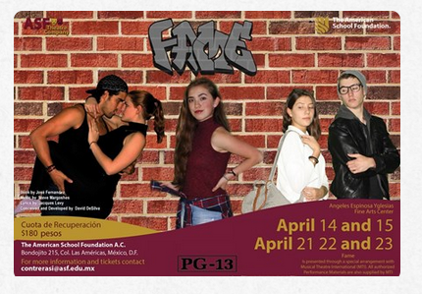

Spring Drama Production - Fame: Tickets on sale April 14, runs April 14, 15, 21, 22, 23!
The Upper School Drama Club is excited to announce this year’s production, Fame,
which will open on April 14. Click here
https://www.youtube.com/watch?v=zA355N1J5Y8&feature=youtu.be to see a promotional video.
~
General INFO!

Check out Vicolo Roma at https://www.facebook.com/vicoloroma/ 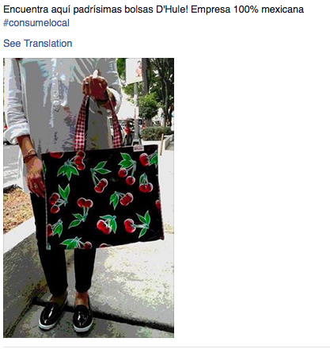and 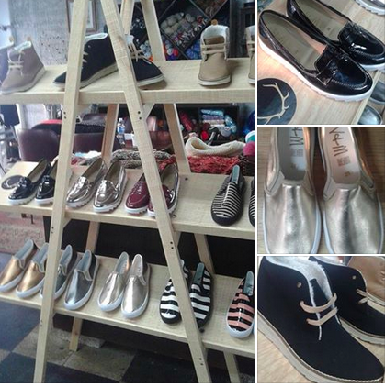
Classes for crochet and knitting by Karin are on Tuesday from 12 till 7pm and Friday from 4pm till 8pm.

Classes for sewing and creating dolls and puppets with Julia Martínez are on Monday from 4pm till 7pm and Thursday
from 12 till 3pm and from 4pm till 7 pm.
REMEMBER! (More below)
Vicolo Roma (Cordoba 97 in Roma Norte) - https://www.yelp.com/biz/vicolo-roma-m%C3%A9xico offers discounts with Id’s to ASF staff – Vicolo Roma is a center for artisans with many new artistic pieces and collector’s items – check it out! Like to sew, knit, or crochet? They have a special gathering just for this as well! 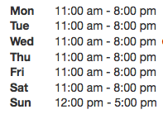 52 55 5208 0125
~

~

Thursdays!
At Vicolo Roma (Cordoba 97-B, Roma Norte)
Classes for sewing dolls and puppets with Julia Martínez are on Thursday
from 12 till 3pm and from 4pm till 7 pm.
~

FRIDAY

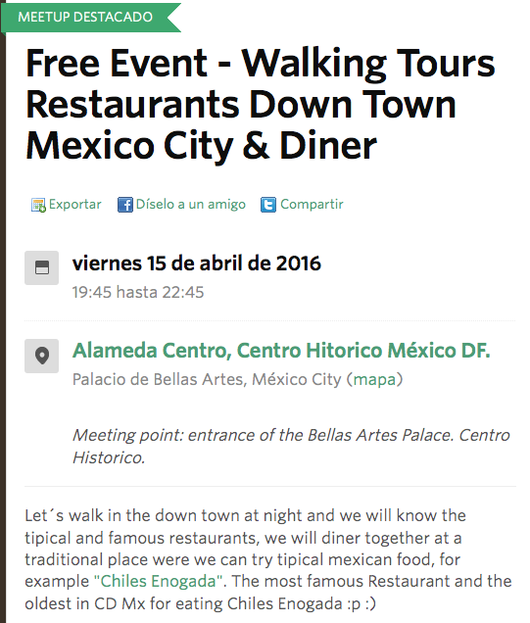
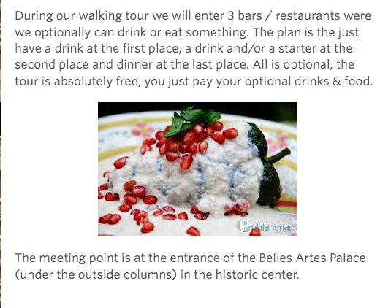

and…

Remember!
A Vicolo Roma Cordoba 97-B Roma Norte
Classes for crochet and knitting by Karin are Friday from 4pm till 8pm.

~
Saturday!
THIS WEEKEND!
http://www.ccromacondesa.mx/maraton-filter/
Cooking classes, Cobain Documentary, TONS of art and MUCH MUCH MORE!

ALSO SATURDAY!
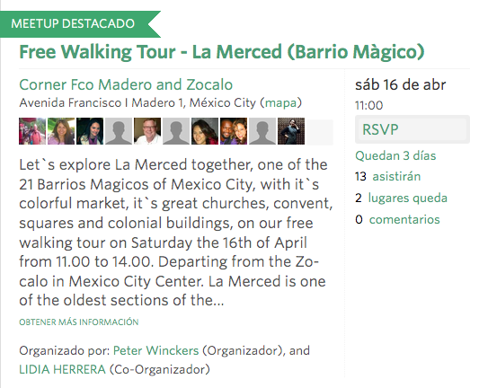
SUNDAY !
REFORMA WALK
And
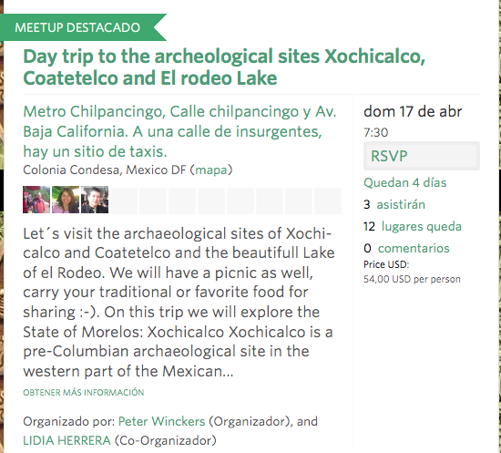
April 16th ….
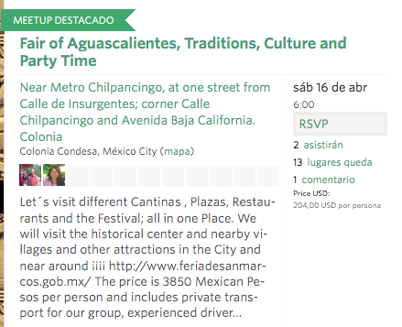

~

Book club session at Milo’s (Condesa)!
Starting at 10:00 AM for the late risers – for our Mexico or maybe something else! – book club – if you are interested – bring your favorite topics/books/and we will begin the incentive program again where you receive discounts on books you love! For RSVP– email at allthingsasf@gmail.com!

~
and

COMING!

Lunario in MAY!

~

April 15th, 16th, 17th COLD PLAY here! Check out Ticketmaster! (AT FORO SOL).
~
April 19th! GUNS n ROSES! - 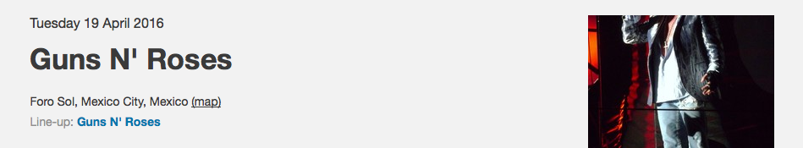
~
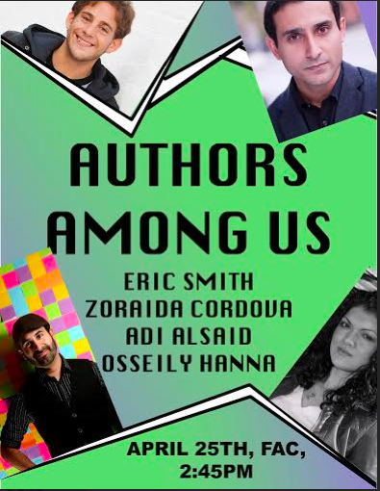
April 25th! Authors AMONG US! https://repentinoland.wordpress.com/events/
See filmmaker/ novelist Osseily Hanna http://musicandcoexistence.com/
Author Adi Alsaid http://alloyentertainment.com/authors/adi-alsaid/
and authors / literary agents Eric Smith, http://ericsmithrocks.com/
and Zoraida Cordova http://www.zoraidacordova.com/
– AND available for specific classroom talks if you request them at asflitmag@gmail.com - just send us how we can enhance your curriculum with them being here!
Live Twitter feeds, book signings and purchases, and a panel discussion for Repentino.’s Second Annual Authos Among Us – this will be AMAZING!

