Follett - Teaching 21st Century Skills in Today’s Library – It’s Not Only in the Classroom!

https://engage.vevent.com/production?eid=4909&seid=34&lc=en&cc=US&regMethod=STANDARD&random=1437221384074

Tweet – @Follettlearning
Facebook – Follet Learning

Jean Thompson
Laura King

Sheila Carr Technical Services
Debby Reiling Library Media Services
Don Rokusek – Library Manager

Challenges – Debby –

Trying to connect with 21st Learners -- How do we do this?
Social Media extending – differentiating connections
Maker Spaces
Sponsoring Clubs
Being in the Cafeteria, in other organizations, and visible! – a new avenue to reach the students in the very other areas we do as libtarians to reach students and encourage casual conversations.

College and career writing – Need more studying, online discussions, extended research, increase in professional reading, presentations – we can provide this!

“When a student needs our resources, it is like going to a speciality store for that new dress…versus using a searching engine…”

Search engines great for basics, but for embedded research, need librarians for that journey.

When we look at preparing students for college, we need to encourage them to use those inquiry based tools to create knowledge, beyond a google search. We need them to parce info. Into usable information and link that info to any given task at hand.

Acquire facts and the procedures to do so, we also want to teach students the process of integrating and using knowledge.

One technique is using Destiny’s ONE Search. Set up databases, and librarians can teach how to fully use that information. Move beyond basic competency and encourage truly academic content – 21st Century Themes incorporated.

Example, teaching Civics Create an online Civics Poll using Pollmaker, (http://www.poll-maker.com/) using tools such as Quizbean (https://www.quizbean.com/home) to create open discussion. This enriches conversations!

Turn a Civics Literacy lesson into an online game! – Using tools like Cyberixx 3-D (check put an example here!) http://www.gamemaker3d.com/ - AND ANOTHER EXAMPLE - https://www.youtube.com/watch?v=QYagqRMI3vc and using Unity 3D http://unity3d.com/learn and here! https://unity3d.com/

Preparation is always a challenge – We need to prepare 21st Century learners – they are risk takers, expressive, always connected and want what is quick and easy. I few provide reliable resources, they are going to gravitate to it, a long term goal.

A federated search – a wide variety of resources with limited effort. We need to look at where we have been and where we are going.

The past – print versions of online resources – why is nonfiction called nonfiction when fairy tales and poetry is there? TRUE! Ideas like calling the nonfiction the Informational Section. (Made more sense to the students – that is most important!)

Special Collections areas created when needed for schools.

Internal pieces – dictionary .vocabularysaearch in ebooks in Follett.

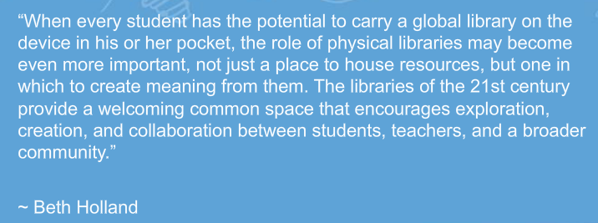

Common spaces are very essential – it is a challenge – funds for remodeling not always there but many cost –effective changes possible. Docking station for laptops and netbooks, and can expand to multiple monitors. Take away fixed stations and give way to maker spaces!

Consider regarding common spaces –
– is it flexible? Does it promote collaboration? Is it comfortable? Does it foster communication?

Blogs Twitter, etc, students already using multiple tools so we need to value their experiences.

Webpath Express – connecting bigger resources to make research more effective.

“Mobile usage has surpassed the desktop.”

Create a library community – use Destiny Manager Library to extend student access to search all types of resources at ONCE. – example – Universal Search in Destiny.

Create a lesson on the difference between basic searches and speciality, quality research.

DailyInfographic.com is a great site!

The Library as the Central Hub for data!

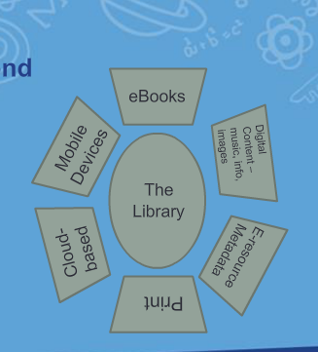

– TEACH Hub is a GREAT GREAT website!

http://www.teachhub.com/50-ways-use-twitter-classroom - Samantha Miller
How to use Twitter and Instagram in your classroom!

Not just to find data but to interpret the data!

Ebooks, e-resource metadata, promote resource discovery, Cloud based research, mobile devices.

We will never get away from print – and still important.
How do we go beyond the How – to’s?

Begin to interpret data, trends, patterns, think critically, make them ask questions, use the Socratic method, work collaboratively, debating, problem-solving. Thinking outside of the box.

Audio books! Ask for 5 minutes at meetings for a new initiative to the library!

Teaching New Skills for New World Success – we can lead purposeful discussion on what works and where to go for the resources they need.

Librarians are the concierges for new world librarianship.

Meeting our students where they are is still relevant.

Resources also that campus STAFF need – important!
Let the teachers share their passion with their students!

Where does Technology fit into all of this?!

Universal Search in Destiny– digital content needs to have easy access, needs to have multiple learning styles addressed, one stop shop.

Find, Evaluate, share – internalize data – interpret and synthesize data.

Pinterest has EXCELLENT ideas for Digital Literacy.

Teachingchannel.org – Great videos!

Skype – field reference questions via SKYPE –

Something that contains originality – digital citizenship a MUST.

Plagiarism in the forms of digital content – state standards for libraries that incorporate digital citizenship.

ENCOURAGE Healthy Skepticism!

Search engines control the results – we ant students to go beyond page 1 – and teach them to use additional channels of Google, academics, news, how to use filters, etc..

Info reader, Twitter all help define and customize content for their needs.

Transliteracy – IMPORTANT – literate across multiple literary platforms.

Teaching coding sponsors problem solving and reinforces mathematical concepts.

CreativeBloq.com

Tools that also are beneficial:
Wordpress.com
http://www.scoop.it/
http://paper-leaf.com/
storyify.com
Canvas being used - https://www.canvas.net/

A great assignment – interview bloggers on articles that are tuned into a specific theme or topic!

Use Twitter to reach authors – bring literacy to life!

Maker movement – search #maker or #makerspace – making connections to this movement!

