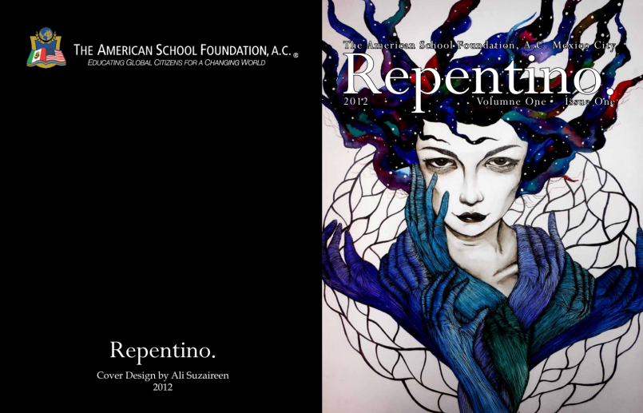

You’re cordially invited

from ASF Upper School Library &

ASF Literary Magazine…

…to attend the Second annual Open Mic Night, tickling your artistic fancy.

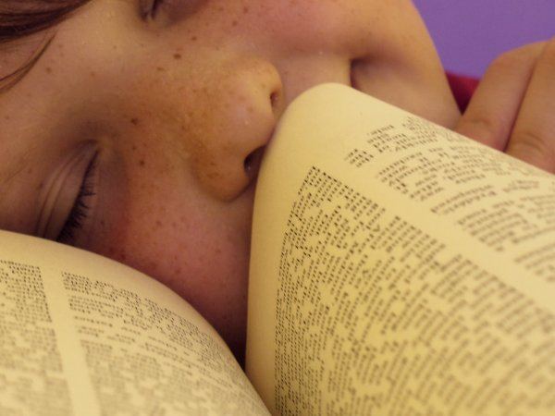

Bring your voice, your creativity, your eyes, and your appetite BACK

for a night of

social fancy, laughter, amazement, and fascination with literary and
dramatic productions of poetry, prose, and powerful literature!

Celebrate the talents of our ASF magazine staff, Upper School library cadets, and generous publisher through our dramatic readings, ASF music, International magazine, and overall local talent.

Upper School Library
Wednesday June 6th
6:30 Reception with food and beverage

