7th Annual Battle of the Bands La Ayuda Concert
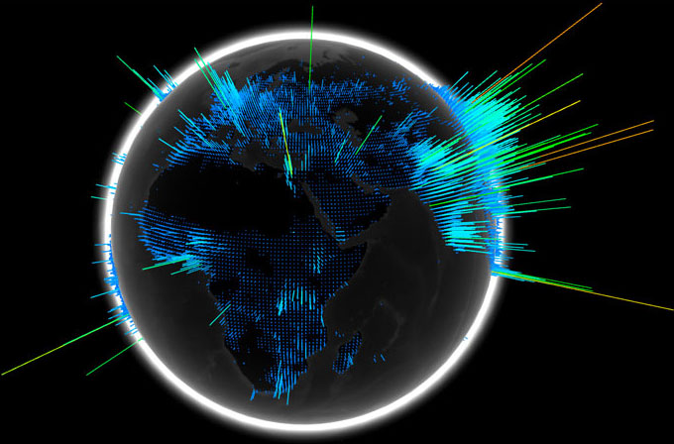

Dane Ohri from New York City,

Chill and the Rabbits,
Family friendly, and safe for all members of the family!
The Jake James Band,

Justin McMullen,

ice box Productionz,

HighGlass Wave,

Awake at Last

and Seaford's own

We are the Weapons.

April 20th- doors AT SHS open at 5:15 PM - 9:30

$7.00 at the door, $2.00 off with your Key Club dinner ticket.
Monies raised will benefit local Seaford charities such as the Seaford Family Center and the Seaford Library and Cultural Center!

For questions, contact gallawayh@seaford.k12.de.us or
harrybrake@yahoo.com
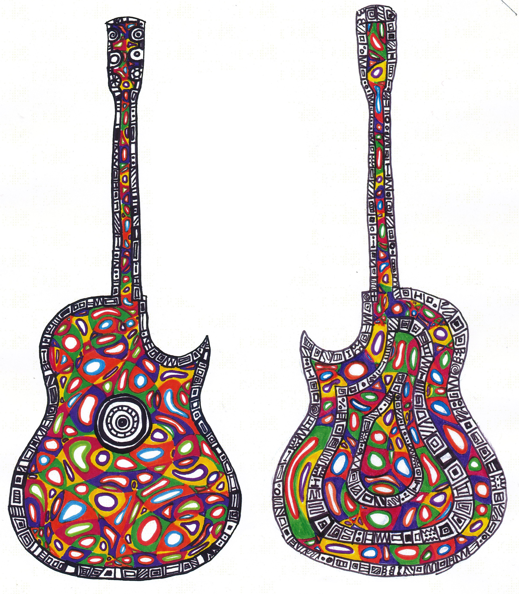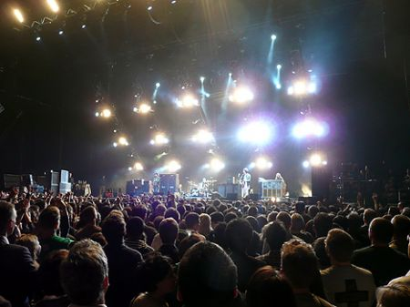
This year the audience decides! The winner!

Commemorative shirts available, as well as the gallery of non-profit info for the public!

