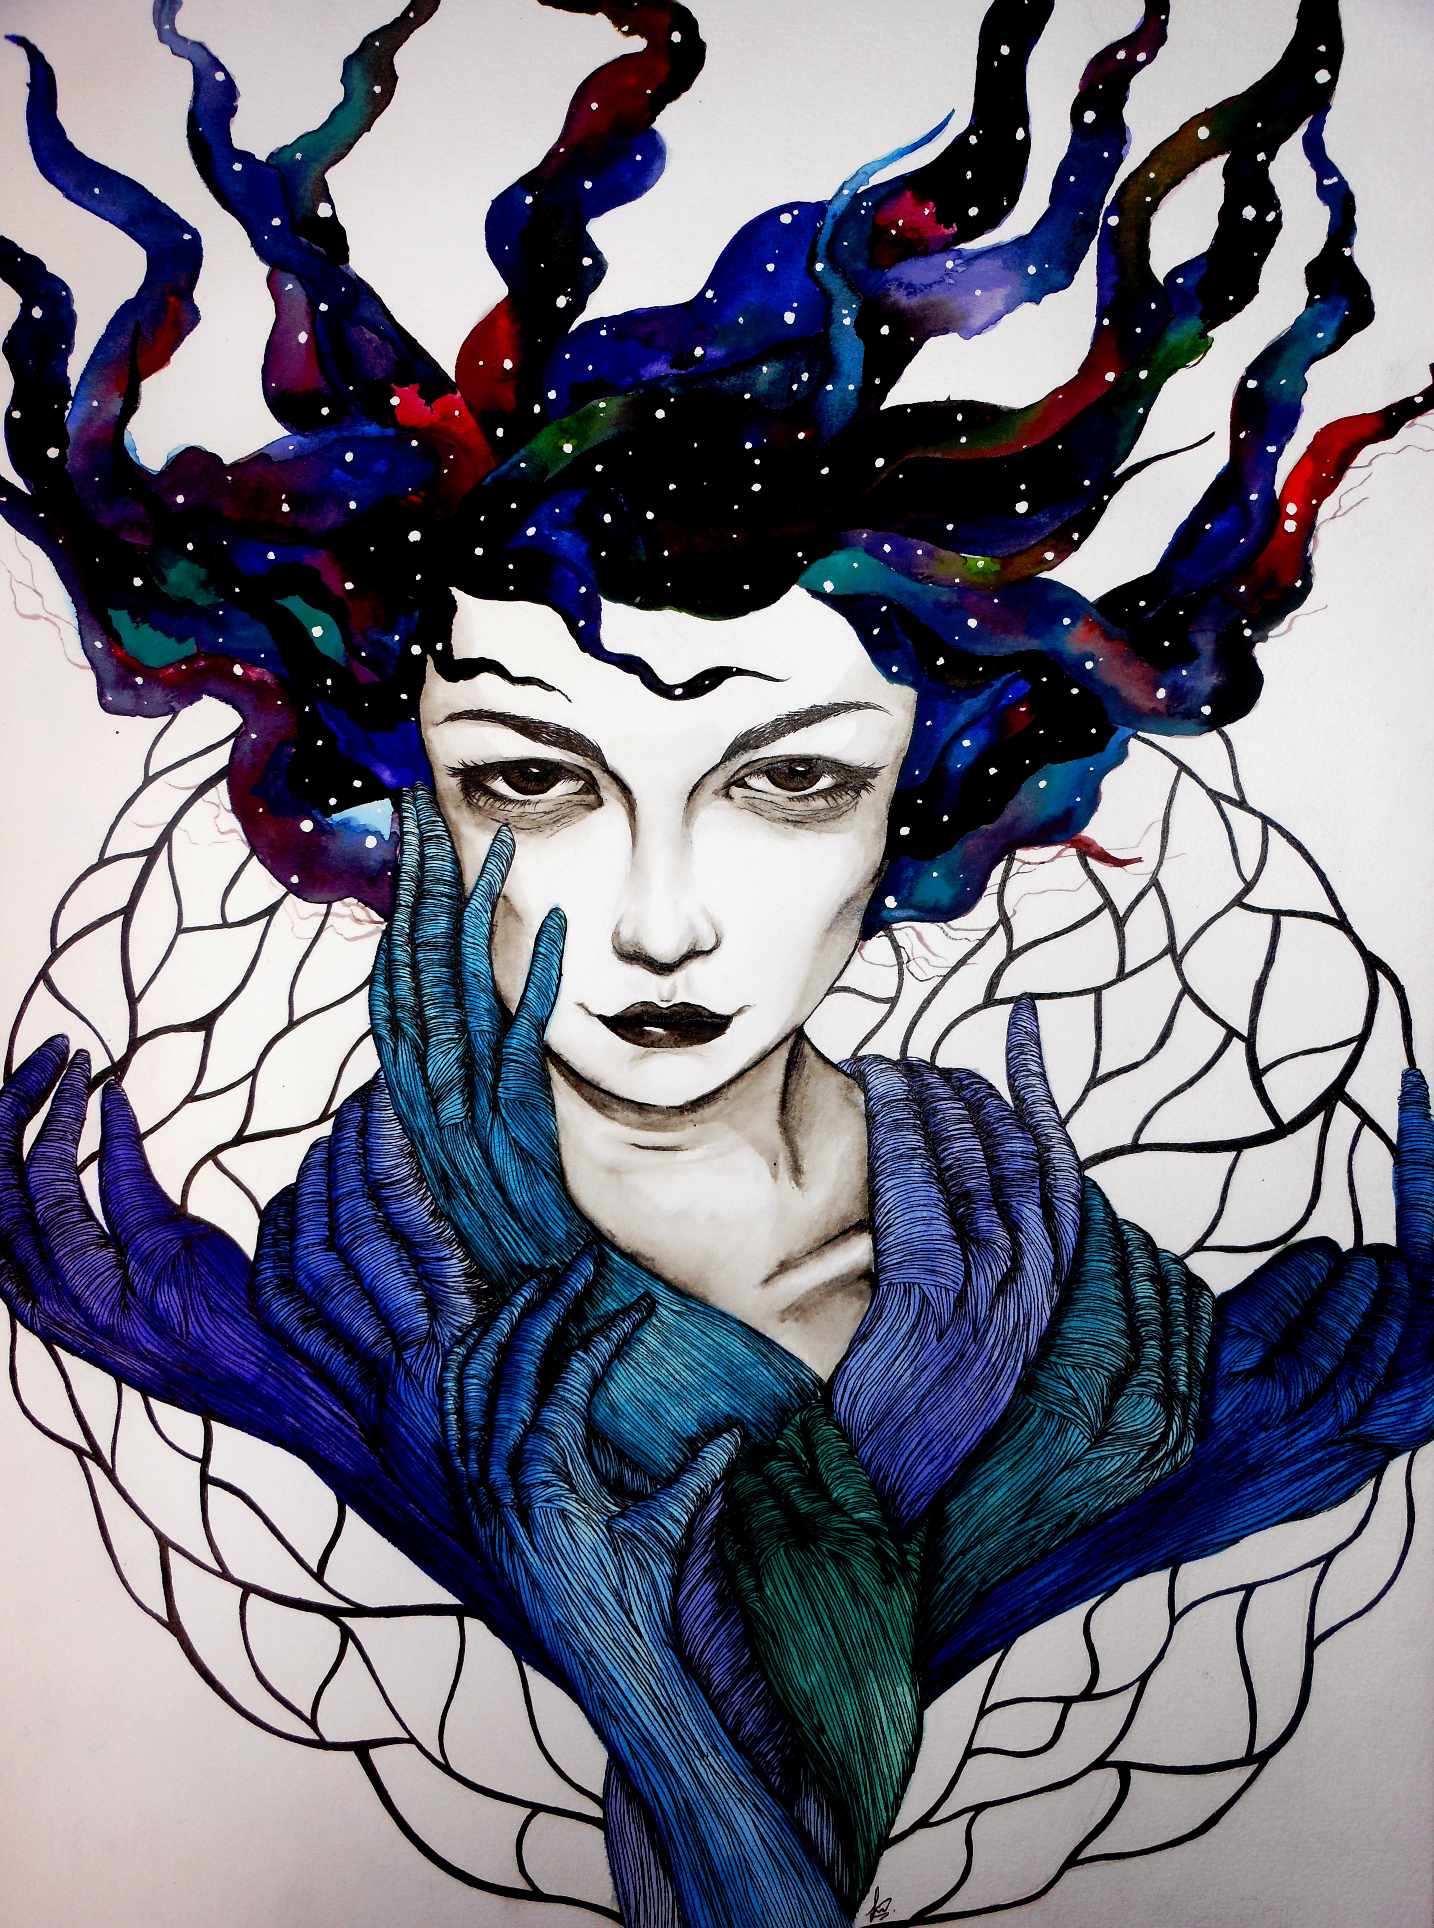
Art by Ali Suzaireen

6:30 PM – 8:30 PM

First Annual Mic Night and the Literary Magazine…

Repentino

