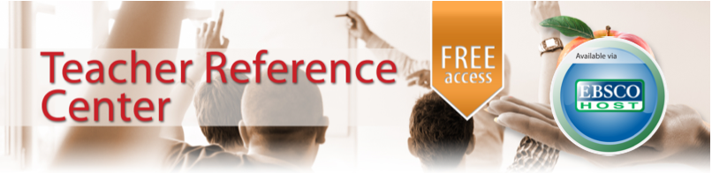
Standard 3 – Information and Knowledge
3.2 Access to Information

LOOK and FEEL:
No different than any other database appearance in EBSCOhost, this is easy to access to selecting from the A-Z databases offered in EBSCOhost. Yet, the acceptance of all the search methods EBSCOhost utilizes allows this to remain a smooth transition of use. Boolean, Advance Search, and specific fields to narrow down a topic are vital, and usable, in Teacher Reference Center. All available menus and options that EBSCOhost offers are available with this database, as again, with EBSCOhost subscription, this is a free attachment to EBSCOhost itself.

“Teacher Reference Center provides indexing and abstracts for 280 periodicals. In addition, 96% of journals indexed in the database are peer-reviewed. Topics include: Assessment, Best Practices, Continuing Education, Current Pedagogical Research, Curriculum Development, Elementary Education, Higher Education, Instructional Media, Language Arts, Literacy Standards, School Administration, Science & Mathematics, and Teacher Education.”
HOW IT WORKS:
To full rely on the Teacher Reference Database, as you enter the initial EBSCOhost screen, you click on the top menu option of A-Z Databases and scroll down alphabetically until you can check only Teacher Reference Database. This allows you to search this database specifically, using all standards options EBSCOhost has to offer. In addition, a trial run of a topic such as “Media Specialists AND Administration, then limiting the date range from 2009 to 2003 does yield three articles ranging from 2011- 2013. Of course, as users are aware, with the manipulation of keywords these three sources will yield, it seems Teacher Reference Center is a database not to be overlooked or ignored. This powerful tool just to hone in on academia and administrative topics is useful when utilized.

Grade: For new to veteran educators, as well as all administration.
Cost : With EBSCOhost use, Teacher Reference Database is FREE!
The Big Picture: Ultimately, this is easy to be overlooked unless you investigate the specific databases EBSCOHOST does have. From collaborating from Early Childhood up to Higher Education, this resource is an armful of resources available at your fingertips, leave the textbooks of preparation at home!

When I recall the many issues I encountered as a new teacher, from Special Education to Standards today, I always recall a text or guide I would refer to help supplement the information. With Teacher Reference Center as a one-stop built-in feature of EBSCOhost, you have the power of multiple areas of education that can also be shared with administrators. Considered an EBSCOhost just for educators, this database is a perfect idea to include educator-specific content that ties together the items students in turn would be searching for. As the description by EBSCOhost indicates, abstracts for 280 periodicals exist, with a high rate of peer-review due to the nature of academic topics that need to be professional. are represented. The vast range of topics covered make this a perfect companion for the educator through all walks of her/her teaching career.
May 14 2013

Teacher Reference Center - EBSCO

EBSCO’s Description:
BY Harry Brake
In choosing this assignment, from Collection Management, which was to choose a specific database resource that would be essential to the Media Center, I was able to go more in-depth past being aware of the electronic resources we use, and go into the background stage of the purposes and ultimate benefits of the resources we have on hand currently. Many times I have found, without being asked, I am aware of the “menu” so to speak, but not aware of the ingredients and the reasoning behind the ingredients. In this case, I did discover that it often goes unlooked that both students and educators need to be aware of why they are choosing a certain product for research instead of just merely accessing it. Also, as cost is pertinent to budgeting and choices of resources, the features that students might not know is as valuable in saving time and creating research efficient decisions regarding using one resource over another in an appropriate situation.

In examining Standard 3, Information and Knowledge, as well as 3.2, Access to Information, it is clear that to enable equitable access to resources, Media Specialist have to be the risk taker in diving in and not only experimenting, testing, and manipulating resources, but also to be able to recommend or not recommend resources to educators and students, as they are on limited time schedules with the rising demands of accountability. With such demands, ”clearing the technological path” for educators and students has become even more crucial in the 21st Century.
GRADE of Teacher Resource Center Database:
The fact that teacher training and a forum of articles specialized for education is important and sends to students and teachers alike the value of up to date and qualified research, journals, and databases to all individuals, including educational professionals. I feel this database deserves an A for carving out for free a place for the above groups of individuals in the search process, as well as ease of use.

FOR TEACHERS AND STUDENTS:
Overall, the fact that EBSCOhost has made an addendum to their database that is free, appealing to educational professionals, without changing the template and capabilities of the search, appeals to the point of how essential the research process, with valid resources are. Being able to find there are specific resources, with very relevant and current dates is reassuring in isolating this database by itself and fully utilizing.

Page 2 Continued

