Standard 1 Teaching for Learning
1.1 Knowledge of Learners and Learning

Question: How does the way a teacher perceives resources or resource provision differ from that of a school librarian? Or, what are the teacher’s priorities for resources?

Creating the “New Normal”, aligning the viewpoints of Teacher and School Librarian

It might seem that the question, “What service or resource from the Media Center/Library do you need to conduct this particular lesson plan?” seems invaluable today, yet, it would have been a question at one point in my teaching career I would not have thought of. However, this change in thought and philosophy of the collaboration between school librarians and teachers has developed with the higher volume on expectations as educators in the 21st Century, creating the school librarian as an overlooked and priceless asset. By allowing this asset of a school library/ librarian more transparent, more visible gains in collaboration and hence, gains in educational achievements will appear. The differences between teacher and school librarian come down to the amount of time able to focus on their immediate and specific audiences, yet, resources for both professionals are vital and rely on collaboration for full success.
Within the first six years of my educational teaching history, I never was instructed, encouraged, or influenced to utilize the librarian or the library as a key asset as part of my teaching experience. This seems as if it would be second nature to do so today, and making such a statement sounds initially like the fault of myself, no one else to blame. This is not to say, in the least, that my program of study in education was lacking in principle. It truly was not, it was just that from the course on learning all forms of media, all forms of hands-on equipment, we were expected to carry this responsibility of resources on our own shoulders. This seemed natural as we were training to be responsible for our own classes, our own materials, and be self-sufficient educators. This was a teacher, getting the resources we needed and getting the job done, on our own. Instead of making trips to the library to learn how to utilize collaborative and interactive media, we accessed texts that lead us directly to books, both juvenile and young adult, but the reliance on the library at that time was not implied to a very high degree. I have to admit, the first six years, I found myself as an isolationist, depending on my own knowledge, my own theoretical base to acquire the resources needed to plan, create, and implement. The questions designed on the Curriculum Mapping Data Collection Worksheet mattered little to me in retrospect of my initial first six years of education. “Materials:” would undoubtedly be in the area of the Internet, textbook, and additional and related books acquired from the school’s bookroom that has been issued to the student. Undoubtedly, the “Library & Information Services:” would have remained a blank or an unused part of the Worksheet. I would also say about 80-90% of the time, the “Organization of Instruction:” would also have been almost always as a large group. Yet, change would be in the wind.
I remember walking past my library in high school as a student thinking how disappointed I was that I did not have time to read the books I wanted to and just explore. Yet, I never looked at my library other than for the books I was missing out on, as well as a place to retreat to, for quiet study. As I found myself reflecting back from my progression as a student in high school, to again relying on the library for a study area in college, to my isolationism of developing curriculum in my first six years as a teacher, I see my second six years as a teacher with a completely new paradigm. Having been a teacher for six years, then being exposed to Mansfield’s program as an interested individual of research and new information, halfway through my second six years as a teacher, something clicked. I was surrounded by a new concept, the fact that a librarian would reach out and sit in on faculty meetings, suggest options for the class, go beyond what I knew of as a “home base” for librarians and see the impact the library could have on curriculum planning. It might have sounded odd to say then, yet, the proactive nature of my school librarian influenced how I handled and manipulated the elevated stress of teaching I experienced in my second six years. Certainly my second six years were more stressful due to state score expectations, higher levels of planning and curriculum meetings, and shifts in administration and staff due to the state expectations. My main goal was a teacher was to deliver, deliver, deliver. I mixed that with characteristics of myself, seeking out creativity when at all possible. Yet, the questions on the Curriculum Mapping Data Collection Worksheet of “Materials:” and “Assignment/Evaluation” grew in front of me thanks to the school librarian and collaborative nature we were able to build together. Evaluations I would have never thought of, as well as materials, appeared as part of my curriculum design. Web quests designed by the school librarian, materials that were interview kits, databases, and sites designed strictly for opening up the opportunities presented in a textbook appeared, and they had been within fingers’ reach the whole time unbeknownst to me! I realized that my evaluations could and were shaped by the meetings I made time for with the school librarian, and that I could get the demands expected as a teacher done, with the help of my school librarian.
Being a part of the same field of study that helped me as a classroom teacher, I am eternally grateful for the collaboration I had in my last few years as an English teacher with my school librarian. I often had pulled out the complaint that “I could not find time” to sit down with the school librarian to brainstorm, create, and implement. Yet, I found out from the very first planning session, I could not afford not to, in order to bring the results of my lesson to the end objectives I needed to meet. Once made a priority, I found my needs relied on the collaboration between the school librarian and myself. The fields of “Level of Instruction;” as well as “Organization of Instruction;” meant less to me as these began to create themselves based on the planning I did do with the school librarian. What I did wish to see on the current Curriculum Mapping Data Collection Worksheet was additional room for the areas of “Special Accommodations” as I often needed these for IEP students, and possibly an area of transitioning from the current mapping plan to the next lesson plan and/or unit. This allowed the pattern of meeting with the school librarian in a frequent basis, rather than just a trial and error situation. I noticed during the interview with my fellow English colleague, there was no hesitation on the fields asked, as every field could be given an exact piece of information that had tied itself to the library. I was also finding the “Comments” area was filled quickly with notes on specific tasks the class became involved in to show how Ebscohost, Jstor, and small group analysis was used to go along with the choices made in each specific area.
In conclusion, the progression from student, to educator, to educator and school librarian was a rewarding one due to the realization that within my planning agenda, the one priceless asset was the school library and school librarian themself. It is difficult to see that as a teacher alone sometimes, and does take he necessity of exploring the additional resources in planning a school has to offer. As an individual that went on to study as a future librarian, I was lucky enough to see the flipside of this asset and was challenged to be more proactive in emphasizing the power of this position. Yet, many do not and it is vital to get across to the administration, faculty, and students alike that the school library is not just simply a haven for study, for that book that has been evading your time, but a clearinghouse of information that can only add to your expertise, as a student and an educator. It is similar to living in a town where you are too busy working to notice the attractions, yet, when you return with no agenda and no schedule, you notice little details you never had time to pay attention to. In this case the stakes are too high to miss, and experiencing the collaboration of a school librarian and teacher paves the way for riding out the challenges educators have in the 21st Century.

In looking at this assignment for LSC 5515, we were asked to take the results from a teacher-oriented questions such as those below:
Question B: Teacher Perspective
1. How does the way a teacher perceives resources or resource provision differ from that of a school librarian? Or, what are the teacher’s priorities for resources?
2. Discuss the length of the form and the time needed to complete one.
3. Is this prohibitive from the teacher’s point-of-view?
4. How might you implement curriculum mapping to accommodate the teacher’s schedule and still obtain their valuable input?

I do see the aspects of knowledge for learners and learning a huge factor as a media Specialist, by always remembering what aspects a teacher and a Media Specialist need to reach all audiences. Audiences that will be reached will be for the most part students, but not always. It is vital not to fall victim to an “ivory tower” syndrome and lose touch with ways to reflect best practices from all approaches, as a Media Specialist and always a teacher. Supporting the learning of all members of the community means being aware of the needs, interests, and ways that will reach all types of learners - and to do so is to always be creative in finding out what is happening in all areas of the school. This happens by observations periodically of classes, inquiring of educators as well as students, and as stated in the essay above, being aware of the day to day expectations as a student, as a teacher, and of course as a Media Specialist. This insures that by visiting now only these various sources of where students receive education, but by also being a presence in the various lower and middle schools, the aspects of learning on all levels is never completely isolated and forgotten by all parties that are in the “business” to allow education to happen!

STANDARD 1 Teaching for Learning
1.2 Effective and Knowledgeable Teacher

Being an active member of the education field in the year 21st Century holds many expectations that are essential in preparing students for an ever-changing and diverse world. I believe being a successful Media Specialist and Librarian involves incorporating art in the humanities, facing challenges and growing from them, infusing technology, and committing to representing diversity in education. I believe being a participant and visible to students, in many diverse experiences, in and out of the classroom, have equipped me to prepare students for many diverse situations; applying learned skills of writing, communication, and interpreting literature in all facets of life.

Art in the Humanities. Conducting a local tour through the Butler County Associated Arts Museum as the first exercise in my English course set the tone I hoped to portray to my current students. Opening minds to all forms of expression, be it art, music, film, electronic media, and English tones of expression can be found and implemented all around us. In this particular case, directly involving students in a museum representative of local artists, students not only developed their own style of observation, but also realized the arts that can be found in their local community. A connected series of research can continue on after this that activates the Media Specialist talents needed for deeper learning.

Challenges. Challenging students to create a Definition Essay based on a selection of music that defines them, having students pull out a universal theme in a Critical Analysis of a book and movie together, as well the possibilities of holding discussion and conferences via e-mail, Skype, Elluminate, or even forums such as P2PU, equip English students far beyond the scope of what is required, broadening their view of what is possible and what can be achieved. Opportunities of learning can be found in every aspect of a campus environment, which is what excites me about teaching and implementing resources as a librarian and Media Specialist. The proactive role that exists insures that the educational experience will always be a different one.

Technology. In instructing students on how to use technology to their advantage and help open their eyes to new avenues of tools to impact their learning, I find students explore their niche of research and interest if alternatives are presented to them. This is not coerced or forced; educators’ true roles are presenting, guiding, and listening to students. IA media Specialist is to enhance that to a higher level of awareness.. In doing so, learning occurs on both sides of a desk. As stated in my written response to the ways media can be involved in the English curriculum, diversity is extremely important to enable a versatile and open mind to alternative experiences. I believe the use of technology, pop culture, and media all are part of a Media Specialist approach to let students catch on to what English can really mean to them. Creating electronic photo albums, Glogster projects, commercials created in coordination with a persuasive interest topic, utilizing the tools of web design, electronic bulletin boards, and e-mail as methods all enhance the classroom experience and broaden education. I am highly excited to present these possibilities to newer generations and to change students’ views that English involves only a text and notes based education. Connecting technology to real life applications on the form of writing grants, PSA’s, and conducting interviews are a small portion of research and technologically-based skills that prevent inhibiting willing active learners.

Commitment to Diversity of experience. Being involved in education requires commitment, vision, and creativity 24 hours a day, 7 days a week in a rapidly changing world from various perspectives. Having the desire to learn more every day is only one part of differentiating a teacher from and educator. Offering many diverse background experiences to motivate students is a must. Ethnicity, culture, beliefs, practices; customs all must be taken into consideration where communities are connected thousands of miles away in virtually seconds via technology. Having the energy to cover the wide range of diversity is tiring, but at the end of the day, being thoroughly involved in a student’s life certainly is an experience that many can look back upon with satisfaction.

As a Media Specialist and Librarian, I have the goal to reach students as if I were in the classroom. I want no distinction between my role as an educator and that of the Media Specialist/Librarian. I hope to reach into my experiences and serve as a mentor to school districts and students, both college and high school levels. In doing so, I feel I will be fully using the skills and techniques I yearn to investigate.

Six competencies in the SL&IT Candidate Competency Checklist that I find to be the most and least challenging to achieve.

Most challenging
Element 2.4 - Literacy Strategies
Candidates collaborate with classroom teachers to reinforce a wide variety of reading instructional strategies to ensure P-12 students are able to create meaning from text.

In looking at this competency, I see the plight of the educator. The advice I took from my current boss I took to heart – “Do not wait for the teachers to come to you, go to them.” I think the most frustrating aspect of being a Media Specialist and/or Librarian is the expectation to have others as excited and motivated as you are. It is easy to forget the schedule of a teacher and as media Specialist/Librarian, if you take this into account, then I feel the challenges of reaching students and educators within the classroom are broken down lower. While trying to meet the educators halfway and impacting your talents to the classroom, I do feel the challenges can become overwhelming to see these goals met.

Element 3.1 - Efficient and Ethical Information-Seeking Behavior
Candidates identify and provide support for diverse student information needs.

Candidates model multiple strategies for students, other teachers, and administrators to locate, evaluate, and ethically use information for specific purposes.

Candidates collaborate with students, other teachers, and administrators to efficiently access, interpret, and communicate information.

While I do not think the specific ethics are difficult to meet and practice, I do feel trying to meet all the ethical support needed becomes difficult, as there are so many ethical and diverse needs from so many different situations and scenarios! I see this as the trying to meet every need, of every student, in the classroom with so many other expectations on the part of teachers (state tests, discipline, social skills, various talents/skills, etc). Ethics are easy to maintain as a successful candidate as a devoted followed of Media, technology, and research, yet trying to meet such a diverse audience of administrators, students, and teachers becomes the challenge and difficulty.

Element 5.1 – Collections
Candidates evaluate and select print, non-print, and digital resources using professional selection tools and evaluation criteria to develop and manage a quality collection designed to meet the diverse curricular, personal, and professional needs of students, teachers, and administrators.

Candidates organize school library collections according to current library cataloging and classification principles and standards.
I feel the skills and inventory of resources will be clear after the intensive training I have received thus far, the choices will be the most difficult part. I am concerned I will be able to mow what specific tool, and when a specific tool, will be available for use for such a wide audience. I am not doubting that organization will be lacing, I am just worried at the diverse situations will be clear to decide on a specific solution or technique to be applied in a certain instance. The diverse needs of so many audiences will be the challenge as at times, I can imagine how daunting this will seem with so many needs and challenges existing at one time!

Least challenging
  - Knowledge of Learners and Learning

Candidates are knowledgeable of learning styles, stages of human growth and development, and cultural influences on learning.

Candidates assess learner needs and design instruction that reflects educational best practice.

Candidates support the learning of all students and other members of the learning community, including those with diverse learning styles, physical and intellectual abilities and needs.
Candidates base twenty-first century skills instruction on student interests and learning needs and link it to the assessment of student achievement.

I have a feeling the basic interest and reason for studying Library Science, Technology, and Media is for the above reasons! Most students and soon to be library gurus come to the arena wanting to achieve the above things. Just like a student wanting to gain something personal from their education, so does the Library/Media Specialist, and therefore, best practices and personal growth are just two rewards from trying to obtain as much information as possible to assist others grow! Learning styles become the steps to leading individuals to higher ground. From implementing Bloom’s taxonomy, to the idea of dispositions, being aware of the learners and what they are learning becomes second nature base don the education Librarians receive.

Element 4.1 - Networking with the Library Community
Candidates demonstrate the ability to establish connections with other libraries and to strengthen cooperation among library colleagues for resource sharing, networking, and facilitating access to information.

Candidates participate and collaborate as members of a social and intellectual network of learners.

Just as English educators gravitate to NCTE as there are collections of English interests, so do Librarians, Technology gurus, and Media Specialists gravitate towards the network of individuals that try to grow and empower their colleagues. From ISTA to ALA, connections and networking become second nature to those that truly divest their times and talents to what interest them. The resource sharing and facilitating that can be obtained makes the most challenging aspects above easier to tackle and solve!

Element 2.3 - Respect for Diversity
Candidates demonstrate the ability to develop a collection of reading and information materials in print and digital formats that support the diverse developmental, cultural, social, and linguistic needs of P-12 students and their communities.

Thanks to the support of a strong and developed curriculum, I already have such a diverse array of materials, just in my current studies. Organizing and collecting these resources into various folders on my hard drive is an investment itself. The foresight of instructors to give us databases, online resources, and networking connections insure the long-term use of such needs down the road. Such a wide array of materials on various levels is available – with careful and steady organization, as well as a strong network of professionals from instructors to students to colleagues, it is impossible to think that “anyone in the field” would be lacking for resources needed to be successful. Surrounding myself with diverse learners of every age and background insures the application of covering all linguistic, social, and developmental needs, alongside the skills needed to be a proactive Media Specialist.

I chose this assignment, because it says a lot about me from the beginning of this voyage at Mansfield to the end. I like to write and get very excited when I write and my brain thinks faster than I type. Hence, I make mistakes, and often, submit items too quickly without proofreading, in the excitement of the ideas of what I wrote. I have been taught to think more about the content, because the actually feel of what I am trying to get across will not be fully realized if someone cannot get past the mistakes! Additionally, this is the first time I actually had ever heard the term disposition, and then had to fit into a part of my philosophical statement. I originally written my draft from the perspective of a teacher, and it had taken me a long time to begin to see things from behind the desk, as a Media Specialist, which is much different than from that of an educator. I see the power of being able to be more visible and supportive to help teachers, as a former teacher, and this insight helps me be more proactive for the needs of educators. In revising this to align more with individuals in the files that have commented on the power of a Media Specialist, I find myself looking at articles and research seeking out the benefits from a Media Specialist point of view, benefits that ultimately filter down to benefitting educators as well. Aligning with Standard 1.2 is easy n the fact that s a former educator, I strived for going above the minimum required to get points across to students. As a Media Specialist trained at Mansfield, I am able to see the characteristics I can infuse to allow a deeper tie an connection to the curriculum, and bring out talents through access to resources that were limited as a teacher. Being able to document and communicate the impact of collaboration with the teacher and Media Specialist role is even more powerful than just the educator role I held at Community college and the various high schools.

Standard 1 Teaching for Learning
Standard 1.3 Instructional Partner

LSC 5515 Lesson Plan for OPAC (Specifically Destiny) - This is part 1, there is an accompanying worksheet with this lesson plan you will see that will follow.
Mansfield University of PA / School Library & Information Technologies Program  Lesson Plan Template |  | The reason for choosing this assignment from LSC5515, which was to create an instructional lesson that instructs information on an existing OPAC system is that it did initially rely on collaborating with an educational partner in the creation. In reality, this collaboration would occur with a Media Specialist and educator as well, to hone in what information would be made available for presentation to student as was done here with the India Studies class instructors and us, the Media Specialists facilitating information on the resources that could go hand in hand with this lesson. Additionally, this curriculum development preparation serves two purposes, increases an awareness in educators of what the OPAC system in their school is capable of, and providing direct links to using the services the library has at their disposal. This is vital for all educators to know to better serve as instructional partners in a collaborating situation.
GRADE: 10 SUBJECT: India Studies Course (new this year)  TEACHER: Ms Amy Gallie and Isabel Duque  SCHOOL: American School Foundation, A.C., Mexico City | ESTIMATED LESSON TIME: 55 minutes
LIBRARY CONTEXT:  ___Fixed  ___Flexible  ___Combination  ___Individualized instruction  _X_Stand-alone lesson  ___Lesson in a Unit  ___Multiple lessons in a unit  Tenth graders will be taught: A more in-depth look at the functions of the OPAC Destiny, in relationship to research an aspect about India. Basic searches as well as accessing more efficient searches using Destiny will be introduced. | COLLABORATION CONTINUUM:  ___Cooperation  ___Coordination  _X__ Collaboration  ___None | Standards for the 21st Century Learner Goals  Standard 1: Inquire, think critically, and gain knowledge.  Benchmark(s)  Students will accesses information efficiently and effectively. Students will evaluate and extract information critically and competently.  Students will use information accurately, creatively and ethically.  Dispositions Indicator(s):  1.2.2 Demonstrate confidence and self-direction by making independent choices in the selection of resources and information.  1.2.3 Demonstrate creativity by using multiple  resources and formats.  1.2.4 Maintain a critical stance by questioning  the validity and accuracy of all information  Responsibilities Indicator(s):  1.3.2 Seek divergent perspectives during  information gathering and assessment.  1.3.3 Follow ethical and legal guidelines in gathering and using information.  1.3.5 Use information technology responsibly.  Self-Assessment Strategies Indicator(s):  1.4.1 Monitor own information-seeking  processes for eﬀectiveness and progress, and adapt as necessary.  1.4.2 Use interaction with and feedback  from teachers and peers to guide own  inquiry process.
Scenario /overview/content topic:  What are the different tools and resources that I can use when I research within Destiny?  How do you search for a book in Destiny?  What options do I have in searching, from a Basic Search, in Destiny?  What type of information can I find out about a book in this case?  How do I know if a book is available using Destiny? | Connection to Local or State Content Standards and the Common Core Standards if available  Common Core State Standards:  Production and Distribution of Writing  CCSS.ELA-Literacy.WHST.9-10.6 Use technology, including the Internet, to produce, publish, and update individual or shared writing products, taking advantage of technology’s capacity to link to other information and to display information flexibly and dynamically.  Research to Build and Present Knowledge  CCSS.ELA-Literacy.WHST.9-10.7 Conduct short as well as more sustained research projects to answer a question (including a self-generated question) or solve a problem; narrow or broaden the inquiry when appropriate; synthesize multiple sources on the subject, demonstrating understanding of the subject under investigation.  CCSS.ELA-Literacy.WHST.9-10.8 Gather relevant information from multiple authoritative print and digital sources, using advanced searches effectively; assess the usefulness of each source in answering the research question; integrate information into the text selectively to maintain the flow of ideas, avoiding plagiarism and following a standard format for citation.  CCSS.ELA-Literacy.WHST.9-10.9 Draw evidence from informational texts to support analysis, reflection, and research.
Collaboration (including information from the teacher) that addresses student interests):

Collaboration of the Principal - Yoga Instructor, Spanish History teacher who has met the Dalai Lama, and the Librarian that has a record of in-house materials that connect to various India areas abd knowledge of Destiny.

Final Product: We want students to be able to manipulate Destiny and use Destiny as a doorway to other sources about India, and gaining this information, without ever leaving the Destiny interface.
Library Lesson(s):

Lesson 1
Teacher responsible: School Librarian
Students will be introduced to Destiny where they will be taught how to recognize basic features found within Destiny. Also, students will recognize the alternatives to standard resources found in using Destiny. Students will navigate the tabs and see that the search includes not only library books, e-books, but also teacher and approved websites, as well as trusted databases. They will be shown on the projector while sitting at the computers as to what needs to be done.

Objectives:  Goal  Students will become independent learners and search effectively using the library´s resources through the use of Destiny.  Objectives  Students will research making use of the resources available effectively and ethically.  Student will become independent learners and thinkers, in order to be able to find sources; moving from a broad to a narrow scope using Destiny.  Activities  Learn how to use OPAC-Destiny´s features to search.  Identify a specific topic related to India based on manipulating the Destiny search possibilities. | COLLABORATION CONTINUUM:  Product  Formative  The students will familiarize with the different Destiny features and find reliable sources for their topic. The teacher and the librarian work together in guiding them through the process.  Student Self-questioning  Students would assess their use of Destiny, how they can search and browse in it, choosing those sources that they best see fit for their purposes.
Instructional Plan:  ___Resources students will use:  Online subscription database(s)  _X__Websites  _X__Books  Their topics  _X__Reference  _X__Non-print  ___Periodical/newspapers  _X__Others/list  Link to India webpage created by school librarian found in Library Website.  Destiny | Motivation, anticipatory set:  Students will be encouraged to use the search features in Destiny to find their possible India research topic, the librarian will review how to make an effective search in Destiny the OPAC system.
Inclusion, adaptations:
Large view of movements on Destiny via projector in the computer lab.

Three instructors (Librarian, Spanish History teacher (who is an expert in India Studies) and the principal).
Instructional Activities:
_X__Direct Instruction: When we watch Screencast on the OPAC stopping at certain times to explain further points or to discuss definitions.
_X__Modeling and Guided practice: Destiny, use will be modeled by librarian and they will put it to use at the same instant.
_X__Independent practice: Students will apply what they have learned in the lessons with the school librarian, finding sources using Destiny.
_X__Sharing and reflecting: Students will search and seek sources, asking for teacher guidance as needed as well as sharing experiences with classmates.
Lesson reflection:

Excerpted from Standards for the 21st-Century Learner in Action by the American Association of School Librarians, a division of the American Library Association, copyright © 2009 American Library Association. Used with permission.

Annotated Bibliography
"Destiny Lessons." North Delta Secondary School LIbrary, n.d. Web. 12 Nov.
2013.
This handy sites has screenshots that explain a basic search, features found in Destiny and what you can click on as you browse titles.
Instructional Design Project Word Document-
This document does show the different ways one can teach Destiny Use to students as well as provide handy worksheets on topics that range from Call Number to the Basic Search and opening an account in Destiny Quest . The worksheet used was on searching and Destiny features.

"Library Media Home." Library Media Services. N.p., n.d. Web. 13 Nov. 2013.
In this site one can find the link to this OPAC PPT that will serve as a review to those who already know Destiny and an introduction to those who do not. We used it and changed it to fit our purposes.

Collection Arrangement
American School Foundation, A.C.
Upper School Library Grades 9-12
Grades 9-12, Amercan School Foundation,
16,739 titles, 20, 366 copies.
Total patrons on record is 1, 286.
Mexico City, Mexico
Prior to receiving new bookshelves, the arrangement of the library at the Upper School had been the main library floor, all non-fiction, with current magazines displayed off clear plastic racks on the front desk and main pillars. The room to the right, as you walk in strictly fiction. The upstairs contained the room we call the mezzanine, which housed graphic novels, Collegiate texts for SAT Prep, and then inside, a larger reference room that housed, Professional Texts, back issues of magazines, all reference texts, Biographies, DVD’s, VHS videos (not may of those left), and the Biographies. However...
…within the last 3 weeks, we have received six new bookshelves and have shifted the library to now be in the following order: Downstairs, rows of uninterrupted shelves that start with Fiction, then non fiction, biographies, collected biographies, collegiate guides such as SAT Prep texts, and oversized texts. In the former fiction room, now will be residing the periodicals and newspapers, as well as reference texts. In addition, we will be moving biographies into that room as well. We have ordered new, steel periodical shelving that will be slanted to accommodate the newspapers and magazines and allow them to be displayed better. Upstairs will still remain the Professional texts, DVD’s, and graphic novels for now. As many students did not access upstairs for Reference, our hope with all mainly being on one floor for the student patrons, this will elicit students to explore what the reference sections have to offer.
As far as collection development, we certainly have the Dewey Decimal System in place throughout all divisions of our materials. Fiction is indicated with the following spine labeling:
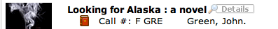
F simply for fiction and the last three letters for the author.
Ebooks are indicated with an E icon to show this:
Brake 2
For non-fiction on the main floor, we have the following:
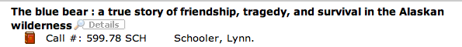
Atlas’s and Maps fall into the same below style for non-fiction according to the Dewey Decimal System. For paperbacks, oversized, and hardbacks, all are categorized the same. If a Spanish text, a green sticker indicates Spanish and the spine would look something like this:
In place of the F, simply the classification number in the Dewey Decimal systems is indicated and with an S or without, depending on Spanish or English. If Korean or French, the same, an F for French (FF meaning French Fiction), a K for Korean. Also, a directory of all the Dewey Decimal System is on display on the stairs, so specific disciplines can be located.
Magazines located along the front desk are as follows on a label, that appears on the front page: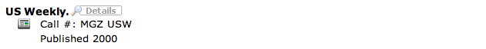
Reference texts include the R prefix and classification number, followed by the cutter to indicate its location as indicated below:
In looking at the College Guides, they indicate with a C, then classification # and the cutter defining the title.

Our graphic novels take on this organization with a prefix of GF and the last three letters of the author:
On looking at the Professional texts, P is the Prefix and then into Dewey Decimal order, while considering the author:
Biographies follow the Dewey Decimal system with author’s last 3 letters of the last name, and a B for Biography:
Brake 3
For the DVD’s, and VHS, we have the following:
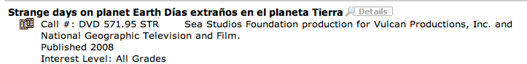
For audio, we have the following (for a recording and on CD):
and for various forms of equipment, (projector, adapter, etc):
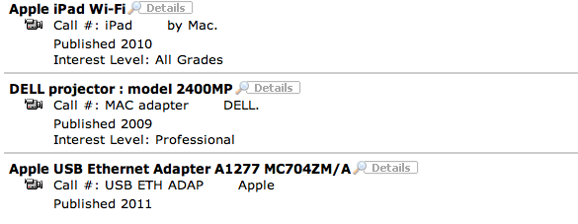
We also have kits categorized, as in the case for a French kit below:
and music is categorized just the same as nonfiction:

Part 2 of Standard 1.3 below:

Link to Destiny Lesson
Name_________________________________________ Teacher_________________________

Using the OPAC (Destiny) Date___________________________

Directions: Use the questions below to guide you through your exploration of Destiny. Do not limit your exploration to these questions. Your goal is to have a complete understanding of the features of Destiny so that you will become an independent library user. Use the spaces below to answer questions, to take notes about the Destiny’s features, and to list questions that you want to ask. Complete sentences are not required.

- How do you search for a book?
- Which type of search do you prefer? Why?
- What options do you have concerning language?
- What type of information can you find about a book?
- How can you review a book?
- What is “Title Peek?”
- How do you know if a book is available?
- What are lexile scores?

________________________________________________________________________________

Standard 1 Teaching for Learning
Standard 1.4 – Integration of Twenty-first Century Skills and Learning Standards

P2PU.org what does that mean? Peer to Peer University!

This will allow you to learn how to write grants, and get possible funding for projects – in the past we have gone to New York City, created a garden in the middle of Seaford, Delaware, gone to the Smithsonian American Museum, as well as work at The Cherry Blossom Festival every year in Washington D.C.!

My former students graduating this year, in Seaford, DE, belong to a club we started 5 years ago – called PAVE – Peers Actively Volunteering and Educating, and they write grants like crazy! They will be working together with you to help you get these grants! They are signed on to P2PU already, and this is how you can too…

First go to http://www.p2pu.org, and find the Student Grant Writing Course:

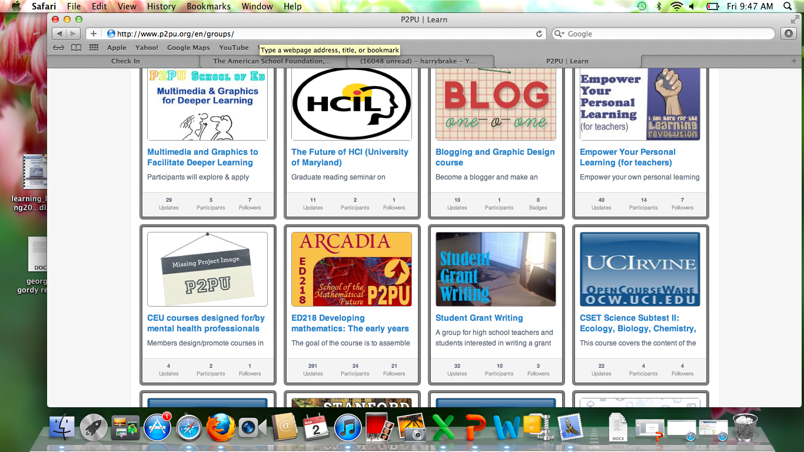

Next click on the course, and you will see this:

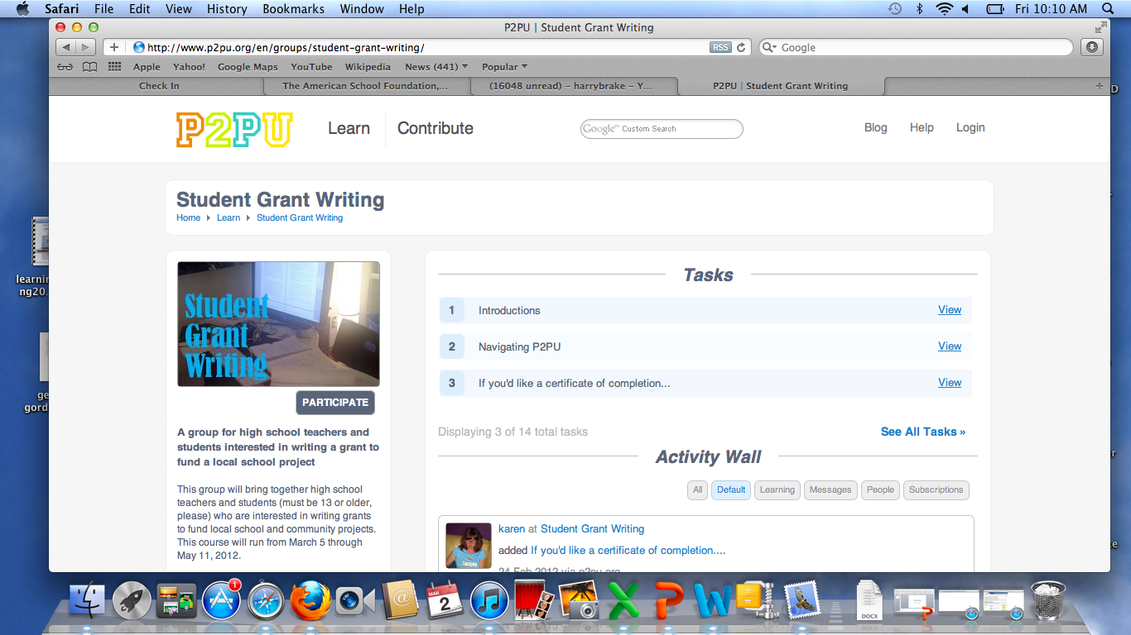

PARTICIPATE allows you to begin to register for the course:

You want to click on “ CREATE AN ACCOUNT:
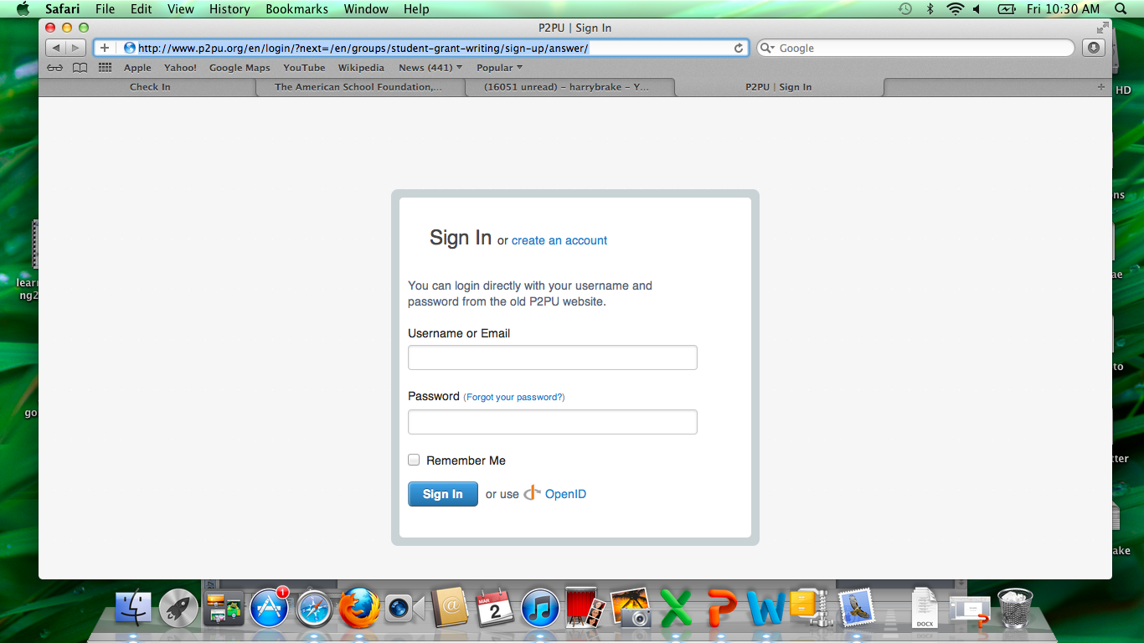

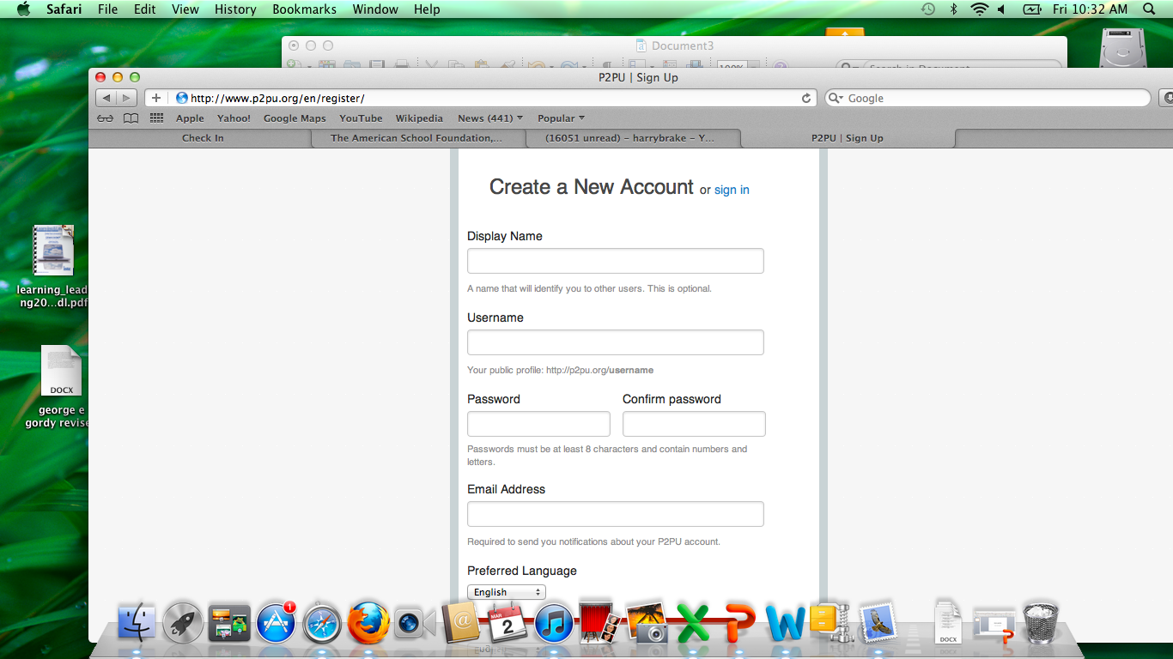
Fill in the info above:
To the right is the place you can write your introductions – there is a small paragraph that tells you what kind of info – DO NOT PUT YOUR LAST NAME, remember, there still are freaks all over the internet even thought they need a password to get into P2PU, so play it safe!

Below – these are short videos to help you know where things are in P2PU!
then you will go to the actual site once you are logged in, this is what it will look like:

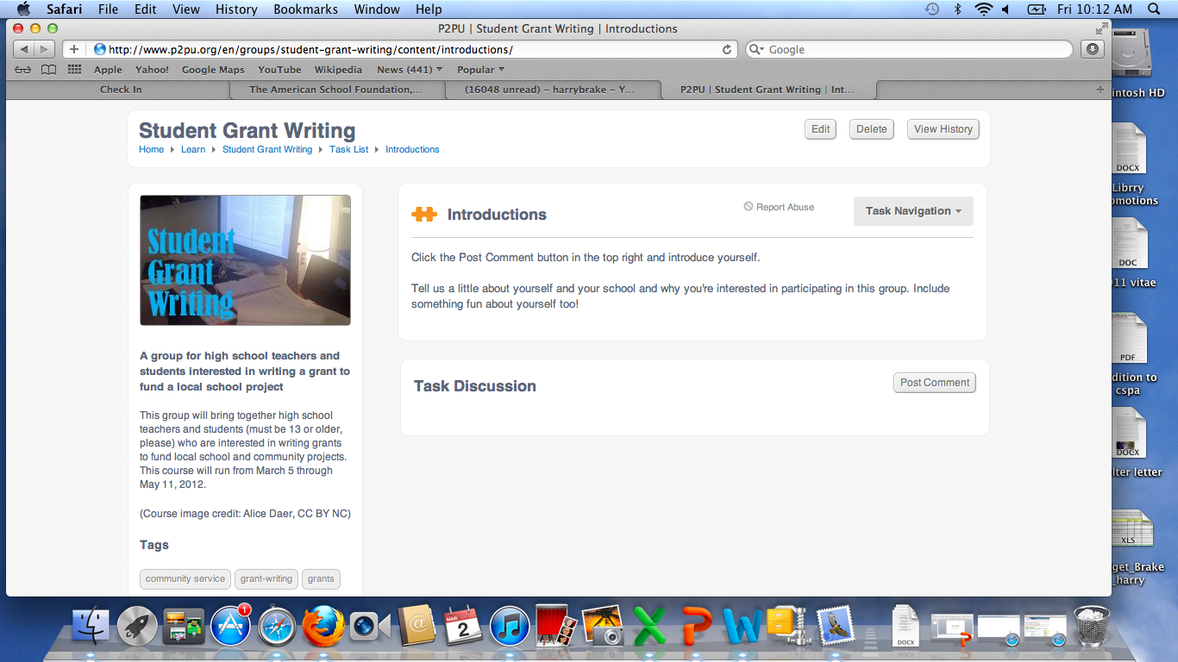

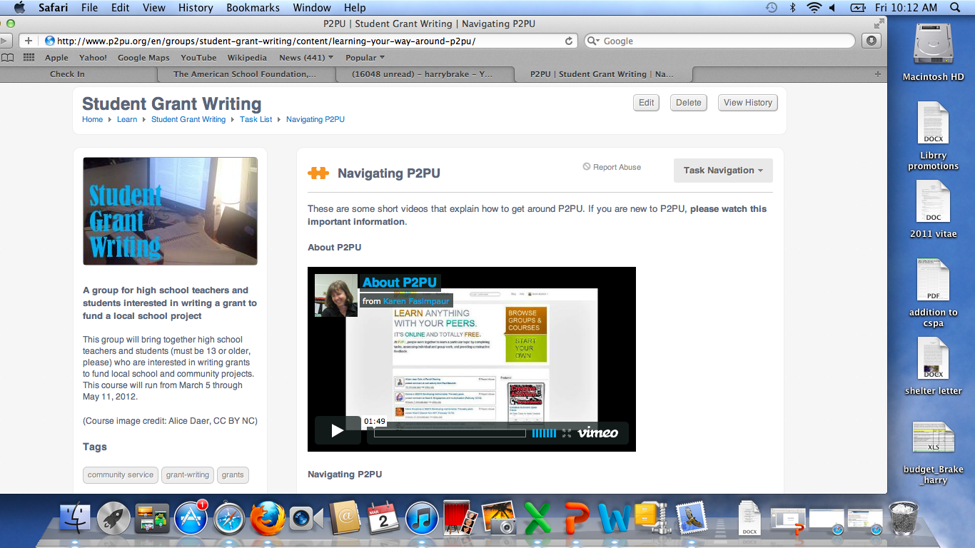

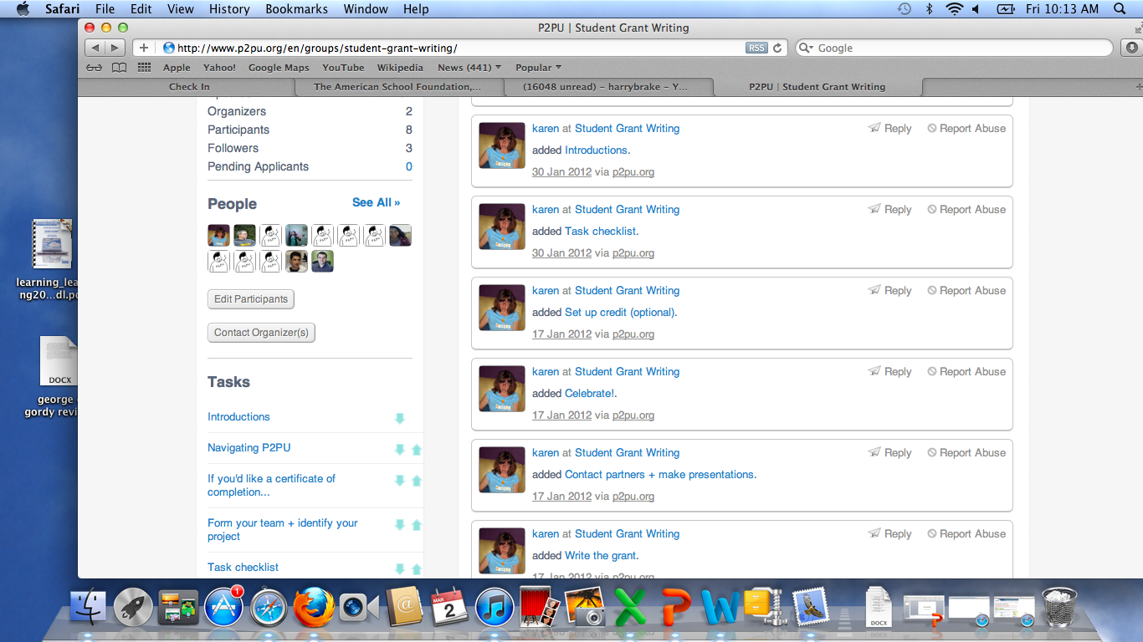
On the left you will see a wall like Facebook where messages can be placed.

Also, along the left, you will see the people already signed up in P2PU –

And list of items below people’s names/pics that you can click onto participate as a class.

Here below, look among the list and find the one that says: TASK CHECKLIST – click on that.

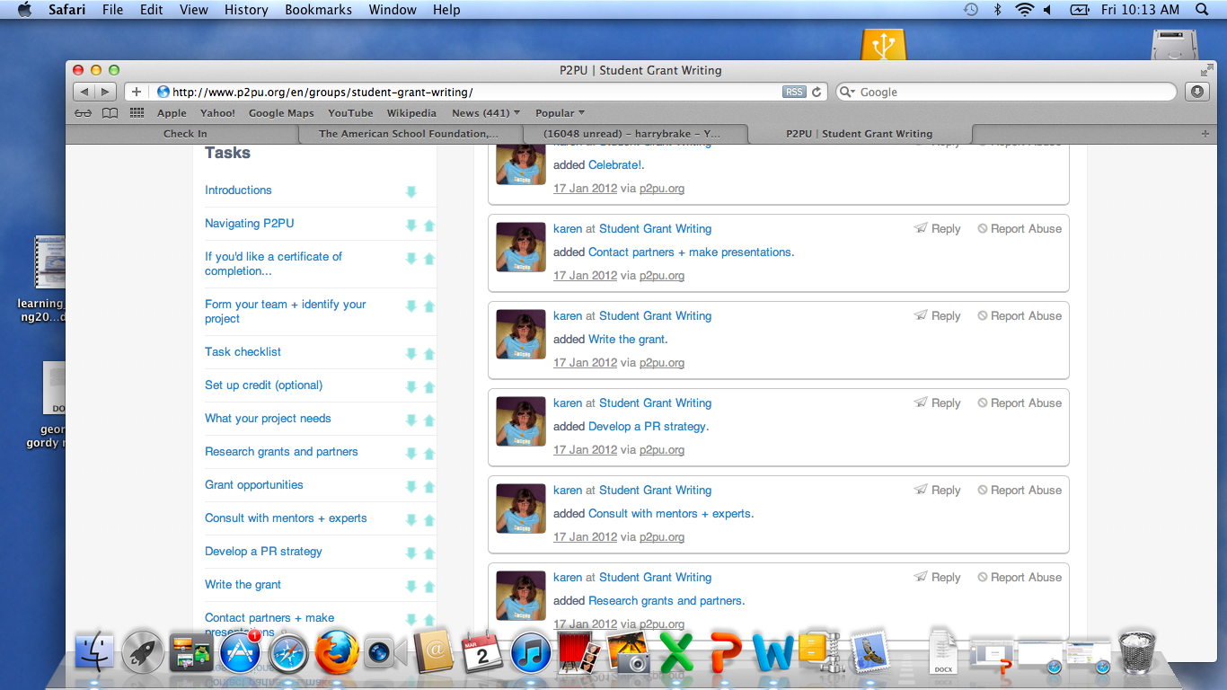

You will see a list of items we need to accomplish before May.

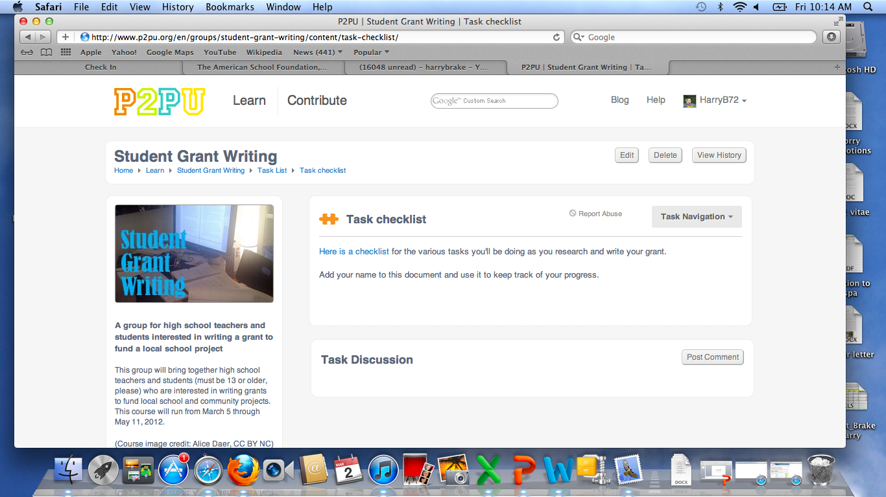

The task checklist looks like this:

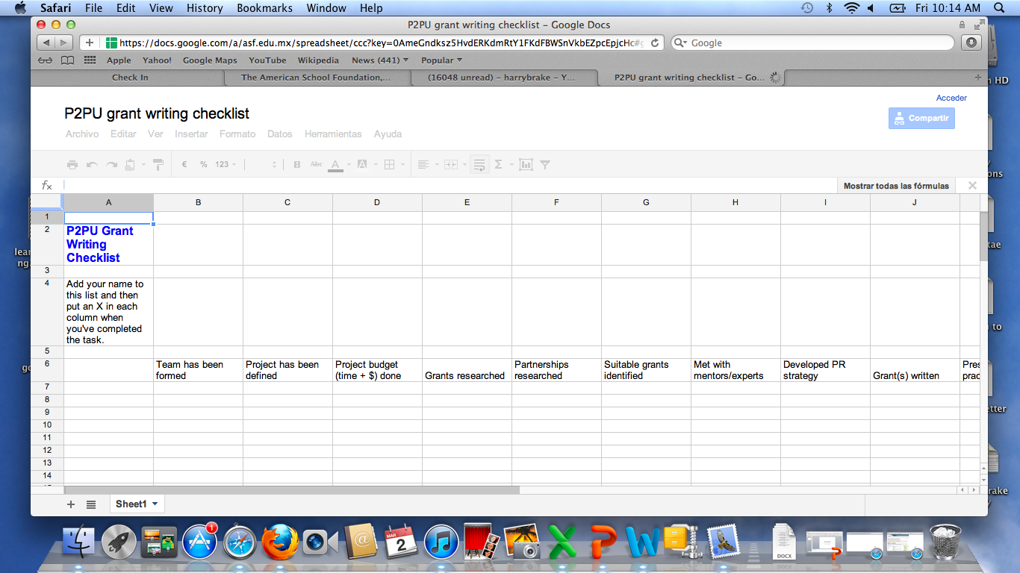

The students from Delaware already signed in will help you with any part of this along the way if you become stuck….

Also, on that original list of tasks, you can see what people have written for their bios: look above the pics of people signed on for the words: non moderated signup, click on that….

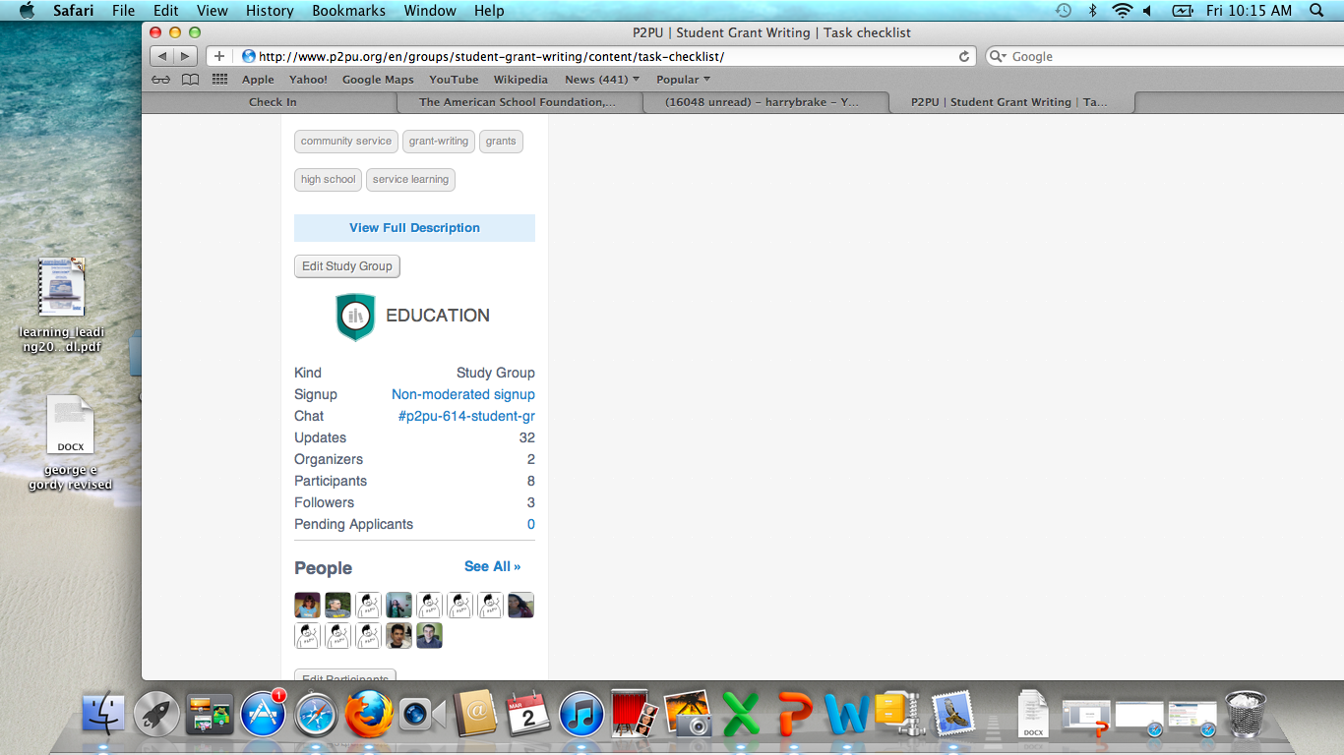

You will see these questions we are asking you to answer so we can get to know your interests, talents, etc… (See below)

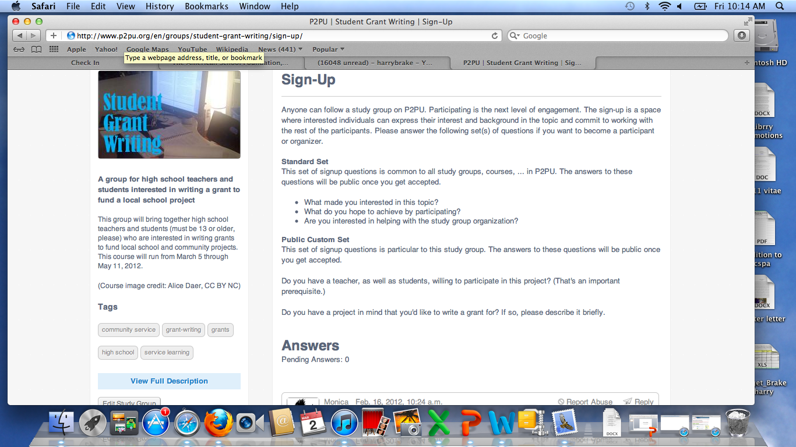

and if you wanted to see some sample profiles of those students signed up for P2PU, here they are:

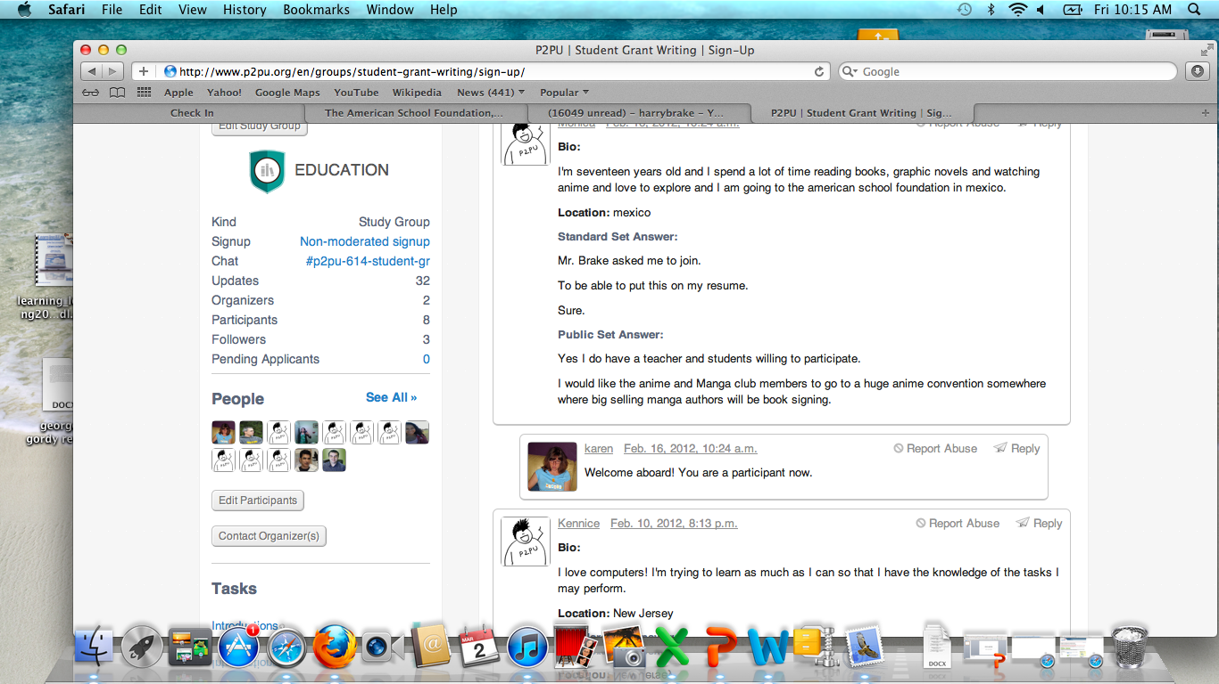

Here is my blog where my students from PAVE keep up to date with things to do and what we have been doing:

http://harrybrake.wordpress.com/pave-a-mobile-idea/

Here is what you will see, they are on the front of the garden they received a grant for:

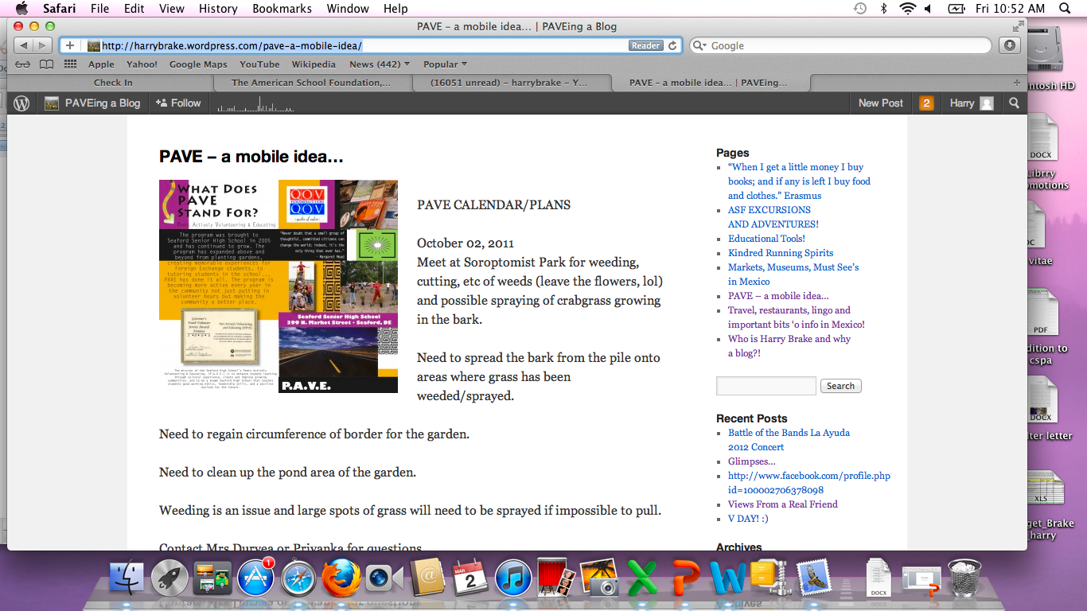

(They have earned over $15,000.00 in grants so far! ) The are excited to work with you as well, and each year we ad our exchange students from countries like Tajikistan, China, Japan, Thailand, and Russia help! April 20th in Delaware they are helping me plan the Battle of the Bands where the earn about $5000.00 USD in one night! This year we are going to donate the money to the Tarahamura here in Mexico! When they go to college, they always get jobs on campus, due to knowing how to write grants, and this is a definite resume builder!

In examining tis assignment for LSC550, I realized this assignment allowed me to create a medium of information with colleagues, that they can bring back up over and over at a later date. This can easily become a talking point for staff in a way that will allow a visual approach to the new topic.

Jumping to the fact that this style serves as a collaborative tool along many colleagues’ paths. I find at least with this resource, P2PU, a wealth of educators from all over who an converge on one location and figure out how to empower students, as well as a new approach to writing involving grants and research. I feel multiple literacies as far as being technology and collaboration are developed with this valuable sire.

