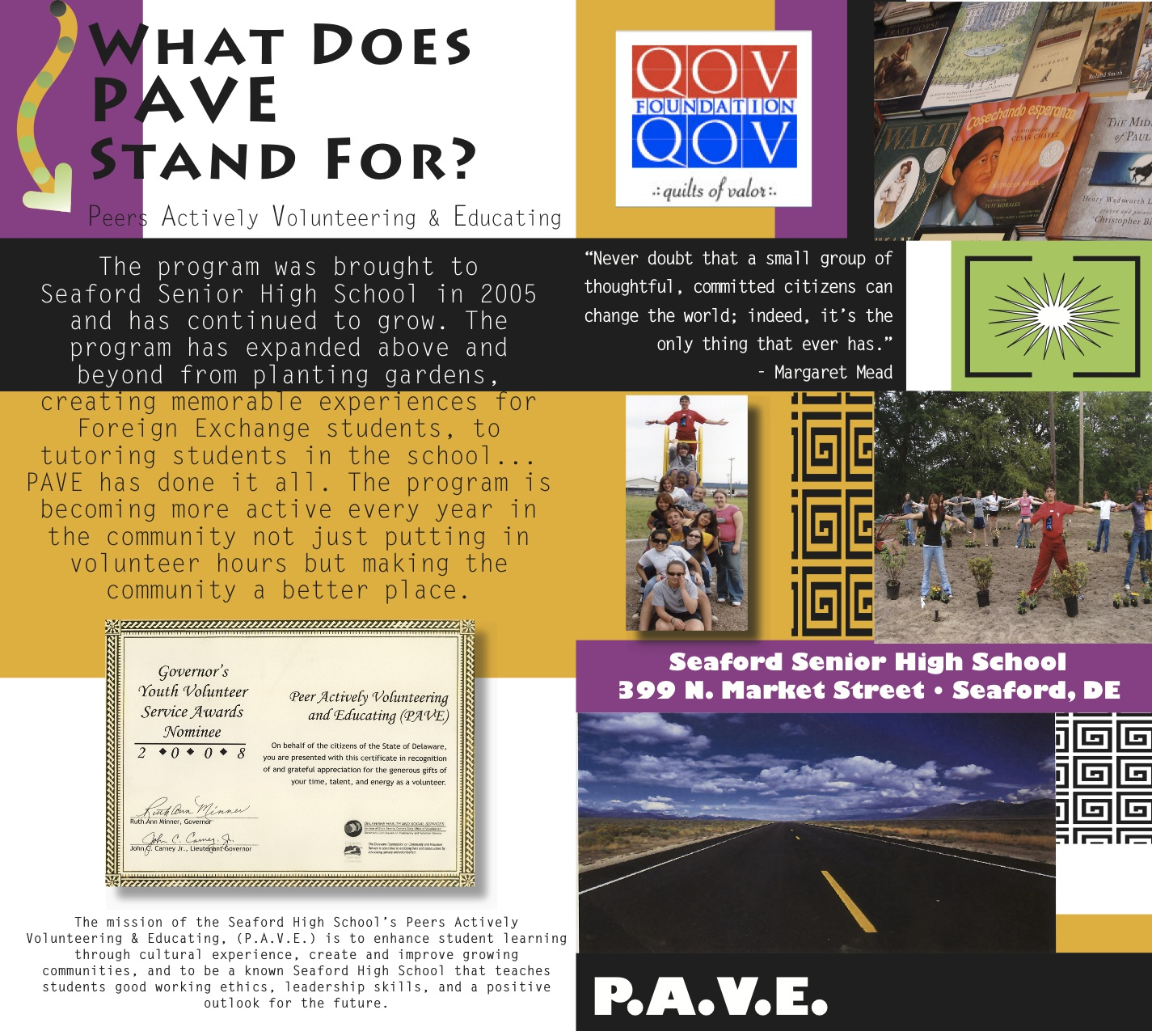
PAVE needs VOLUNTEERS FOR SOROPTOMOIST GARDEN DURING
NATIONAL VOLUNTEER WEEK!

National Volunteer Week 2012
Date(s): April 15, 2012 - April 21, 2012
Location: National
Description

Established in 1974, National Volunteer Week has grown exponentially in scope each year since, drawing the support and endorsement of all subsequent U.S. presidents, governors, mayors and other respected elected officials.

National Volunteer Week is about inspiring, recognizing and encouraging people to seek out imaginative ways to engage in their communities. It’s about demonstrating to the nation that by working together, in unison, we have the fortitude to meet our challenges and accomplish our goals. National Volunteer Week is about taking action, encouraging individuals and their respective communities to be at the center of social change—discovering and actively demonstrating their collective power to foster positive transformation.

National Volunteer Week is not only our moment in time to celebrate our volunteers, but to enable a nation to share ideas, practices, and stories, wherever they happen, and shaping a movement to re-imagine the notion of citizenship for the 21st century.

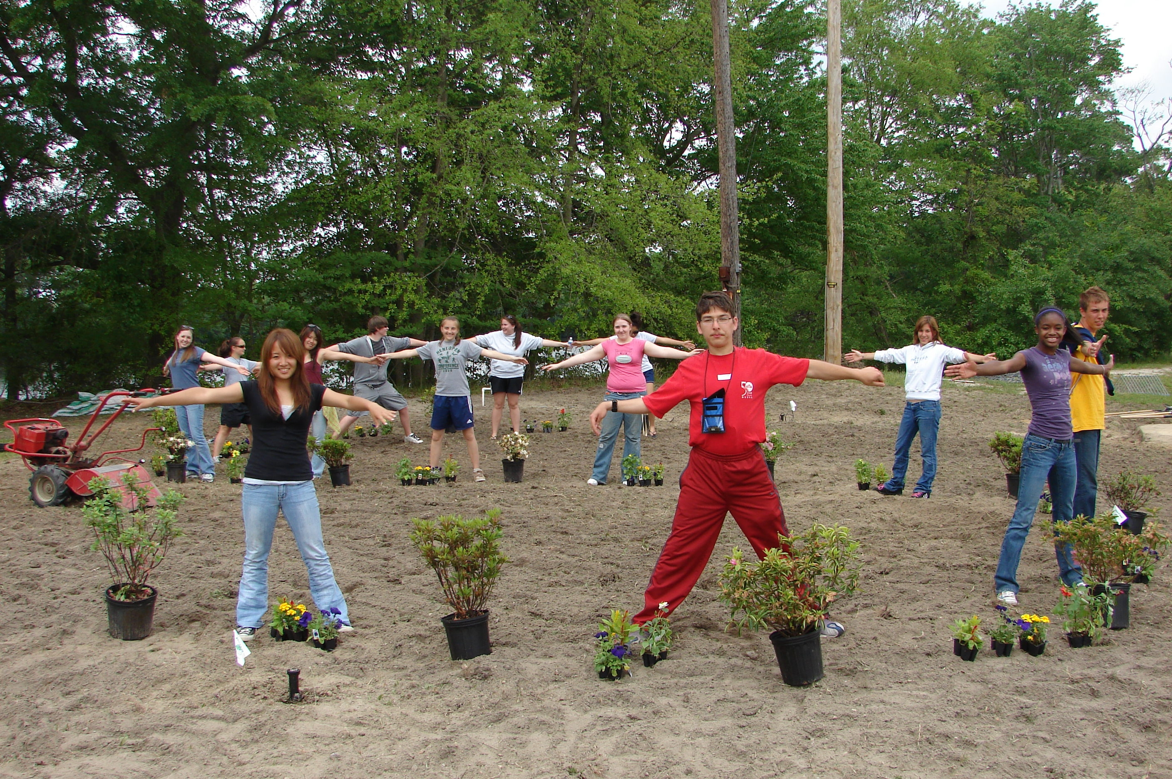

To sign up and gain your FREE LUNCH and volunteer hours, register at the following email:

harrybrake@yahoo.com

