P2PU.org what does that mean? Peer to Peer University!

This will allow you to learn how to write grants, and get possible funding for projects – in the past we have gone to New York City, created a garden in the middle of Seaford, Delaware, gone to the Smithsonian American Museum, as well as work at The Cherry Blossom Festival every year in Washington D.C.!

My former students graduating this year, in Seaford, DE, belong to a club we started 5 years ago – called PAVE – Peers Actively Volunteering and Educating, and they write grants like crazy! They will be working together with you to help you get these grants! They are signed on to P2PU already, and this is how you can too…

First go to http://www.p2pu.org, and find the Student Grant Writing Course:

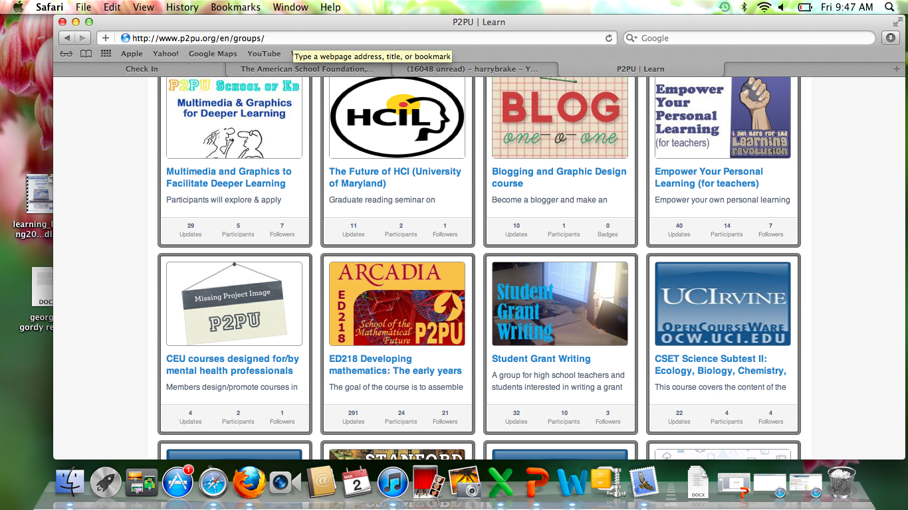

Next click on the course, and you will see this:

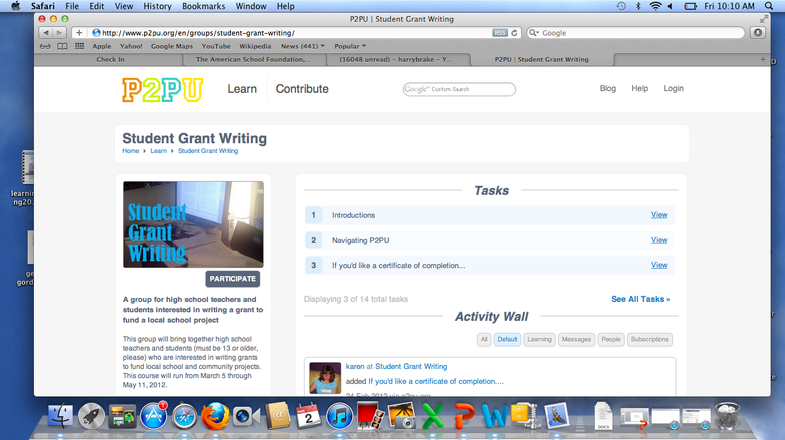

PARTICIPATE allows you to begin to register for the course:

You want to click on “ CREATE AN ACCOUNT:
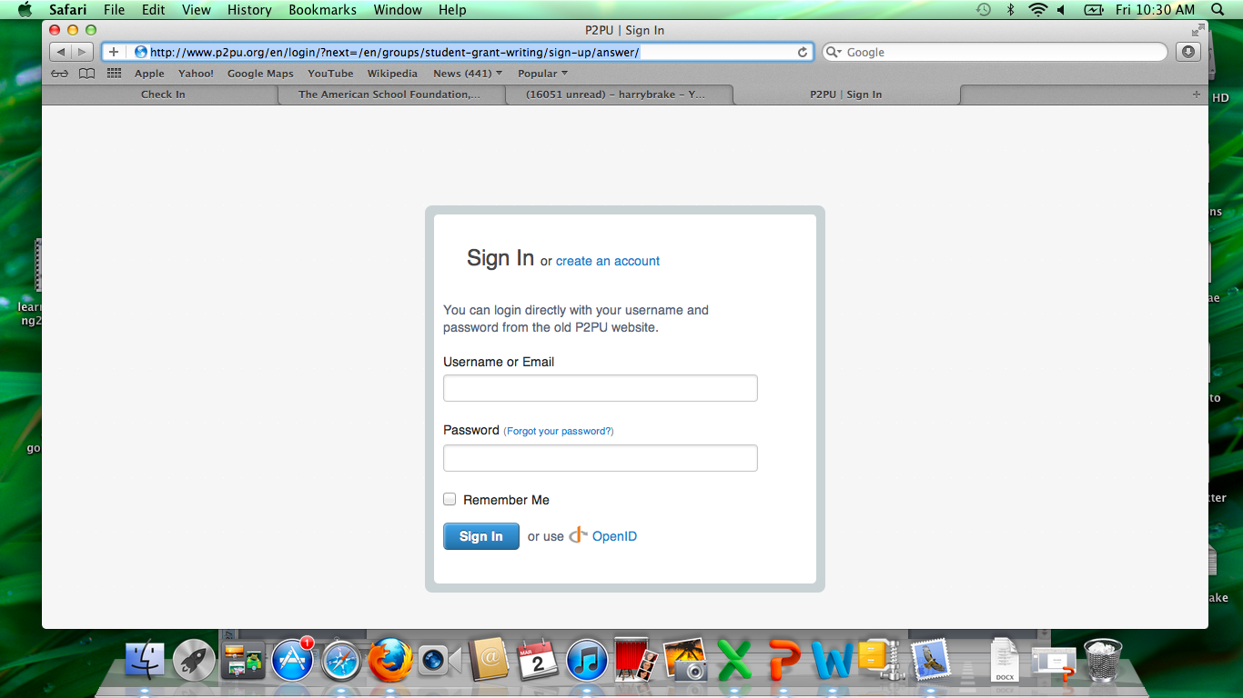

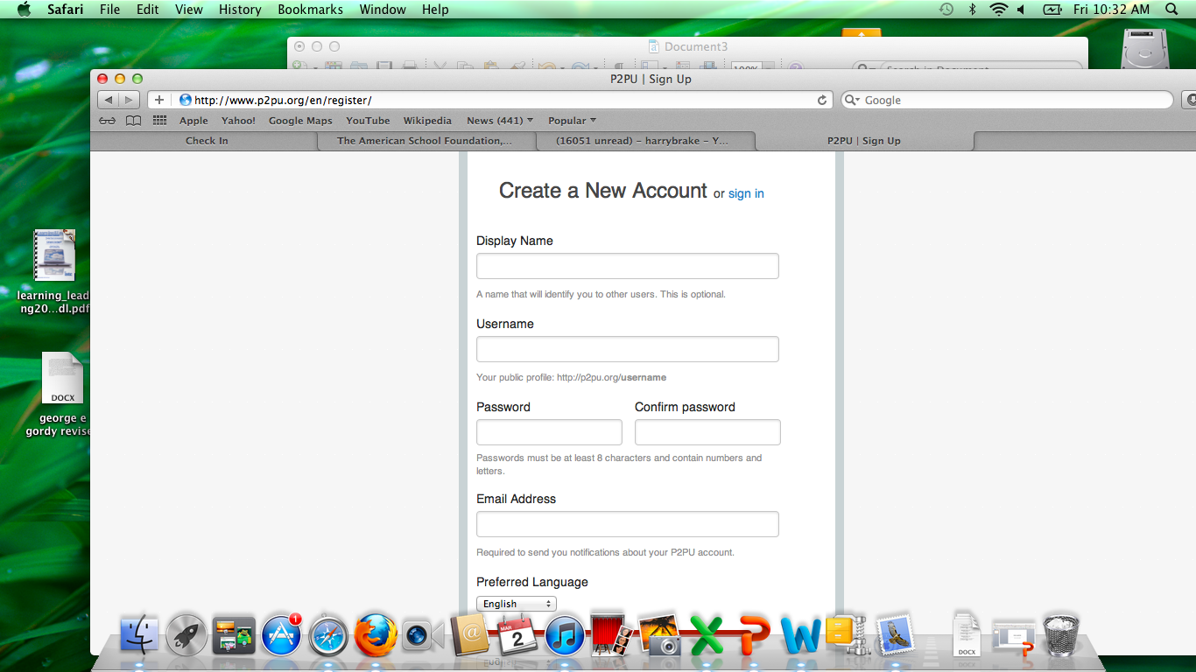
Fill in the info above:
To the right is the place you can write your introductions – there is a small paragraph that tells you what kind of info – DO NOT PUT YOUR LAST NAME, remember, there still are freaks all over the internet even thought they need a password to get into P2PU, so play it safe!

Below – these are short videos to help you know where things are in P2PU!
then you will go to the actual site once you are logged in, this is what it will look like:

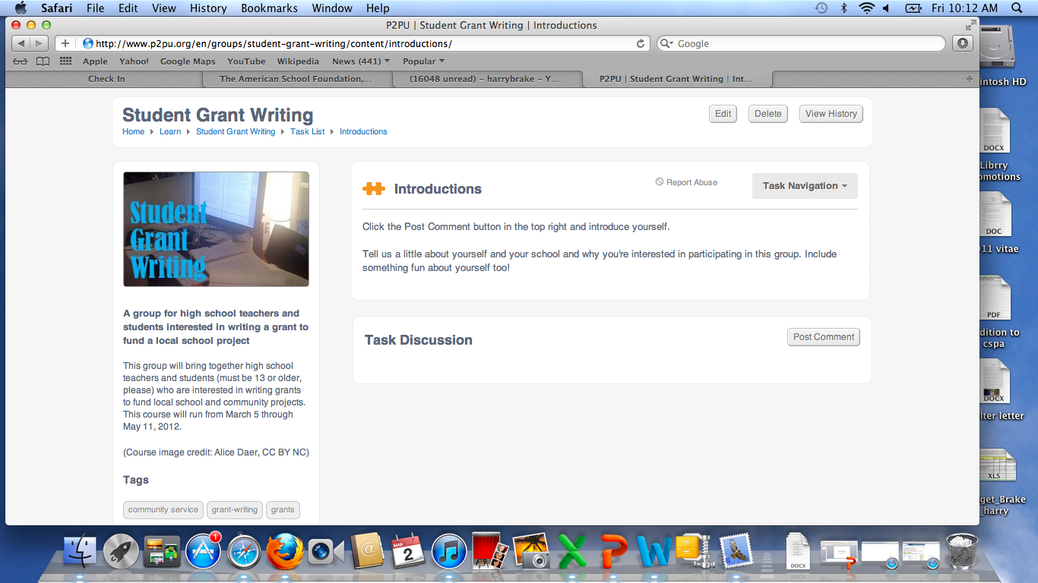

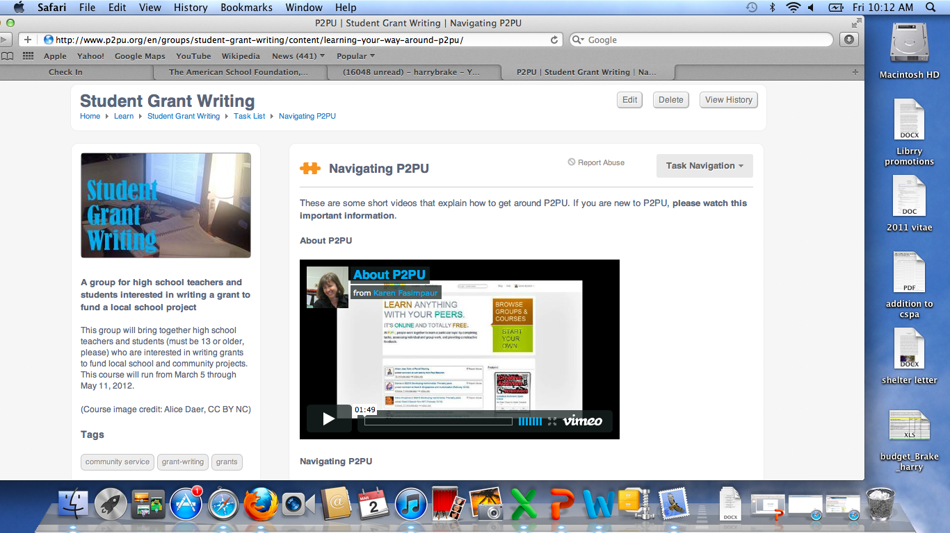

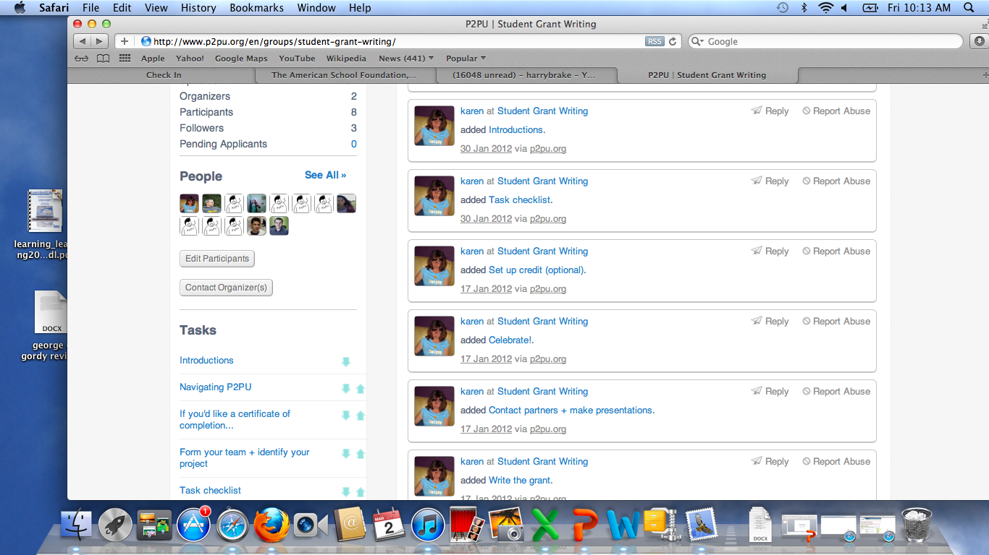
On the left you will see a wall like Facebook where messages can be placed.

Also, along the left, you will see the people already signed up in P2PU –

And list of items below people’s names/pics that you can click onto participate as a class.

Here below, look among the list and find the one that says: TASK CHECKLIST – click on that.

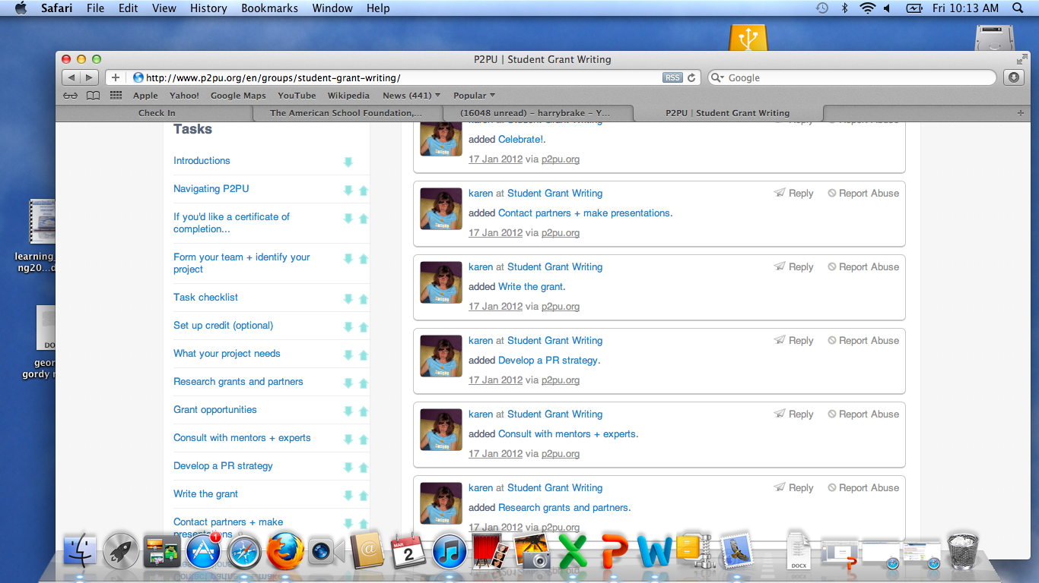

You will see a list of items we need to accomplish before May.

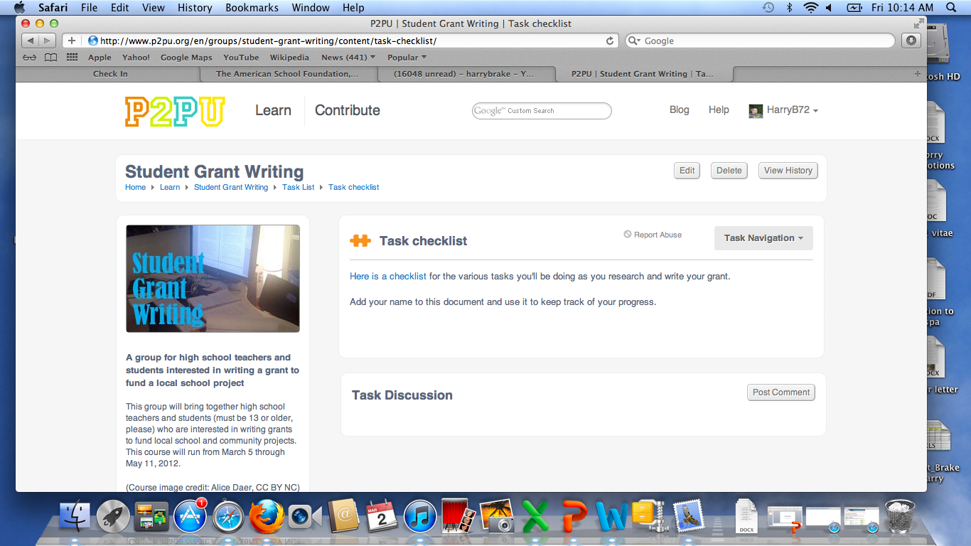

The task checklist looks like this:

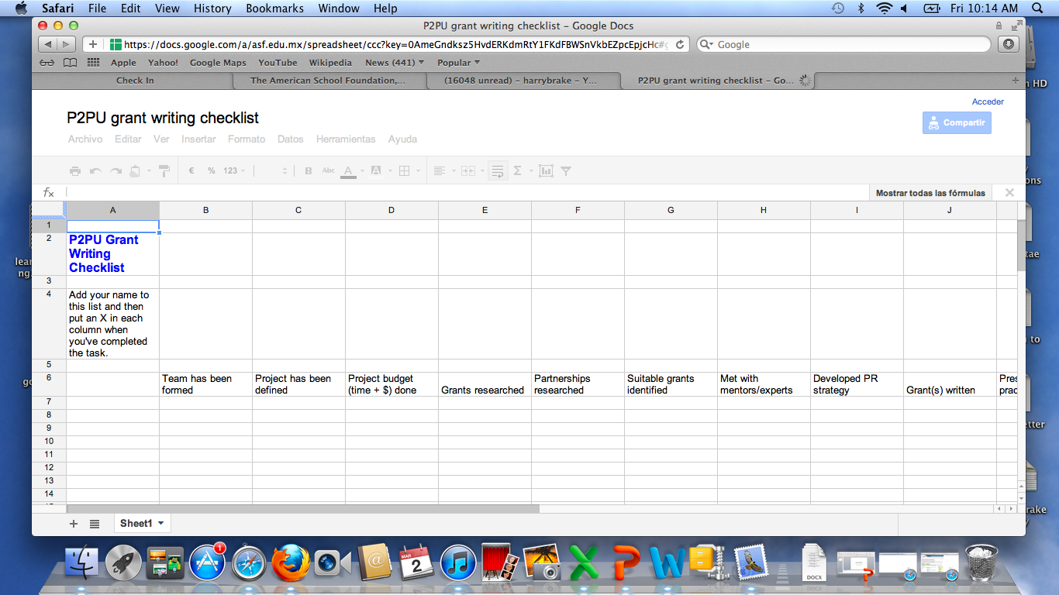

The students from Delaware already signed in will help you with any part of this along the way if you become stuck….

Also, on that original list of tasks, you can see what people have written for their bios: look above the pics of people signed on for the words: non moderated signup, click on that….

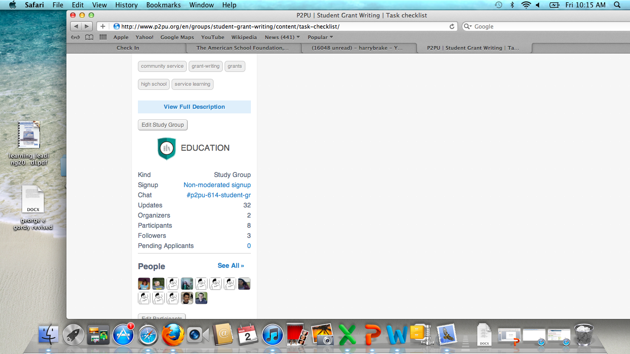

You will see these questions we are asking you to answer so we can get to know your interests, talents, etc… (See below)

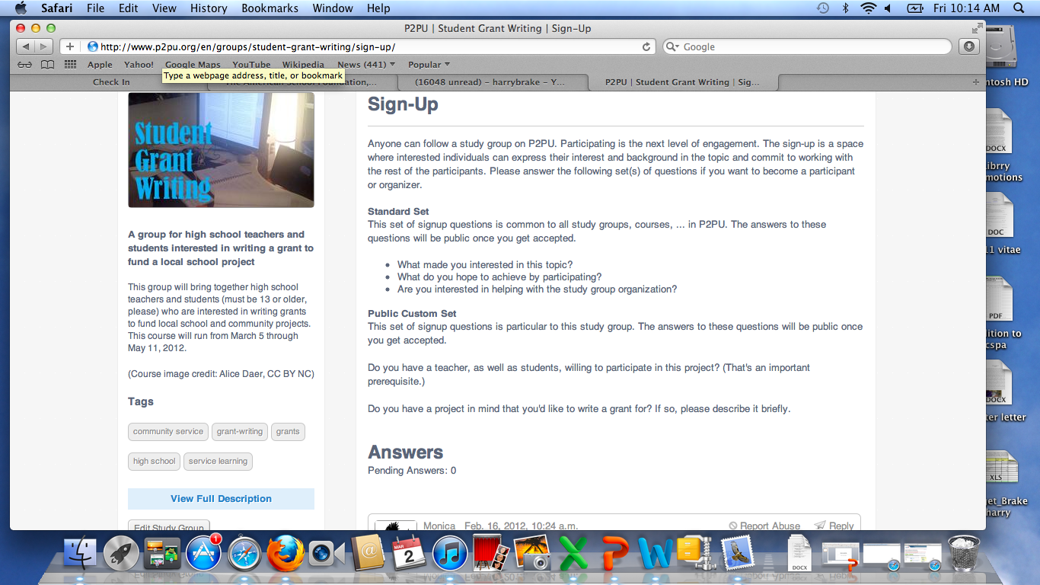

and if you wanted to see some sample profiles of those students signed up for P2PU, here they are:

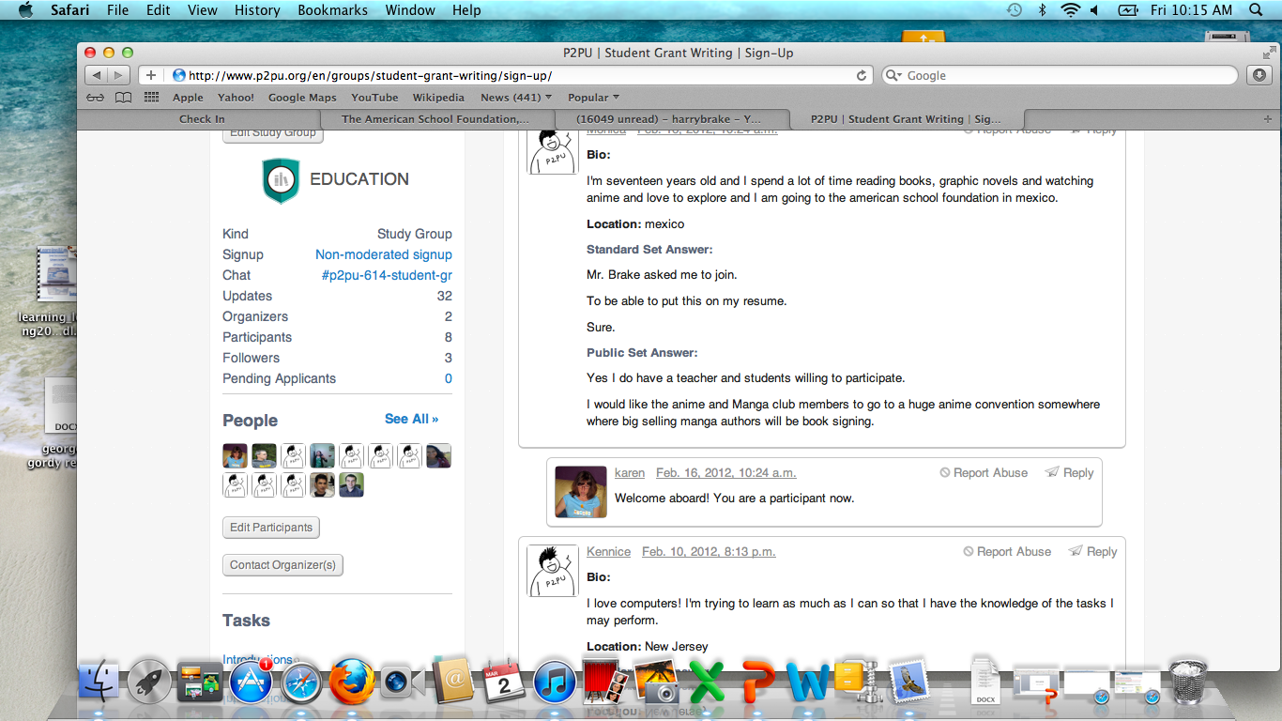

Here is my blog where my students from PAVE keep up to date with things to do and what we have been doing:

http://harrybrake.wordpress.com/pave-a-mobile-idea/

Here is what you will see, they are on the front of the garden they received a grant for:

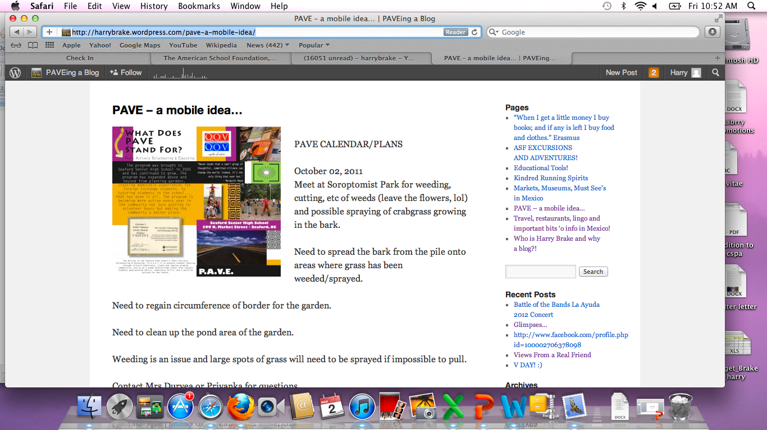

(They have earned over $15,000.00 in grants so far! ) The are excited to work with you as well, and each year we ad our exchange students from countries like Tajikistan, China, Japan, Thailand, and Russia help! April 20th in Delaware they are helping me plan the Battle of the Bands where the earn about $5000.00 USD in one night! This year we are going to donate the money to the Tarahamura here in Mexico! When they go to college, they always get jobs on campus, due to knowing how to write grants, and this is a definite resume builder!

ANY questions, please let me know!

harrybrake@yahoo.com
brakeh@asf.edu.mx

