Do you have what it takes to prevent devastation and hunger around the world?

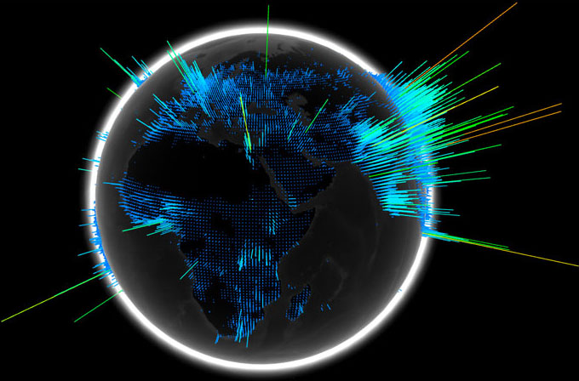

The 7th Annual Battle of the Bands Ayuda Concert gets connected
and International in 2012!

Battle of the Bands’s La Ayuda 2012 Concert is your chance to impact needs in Mexico!

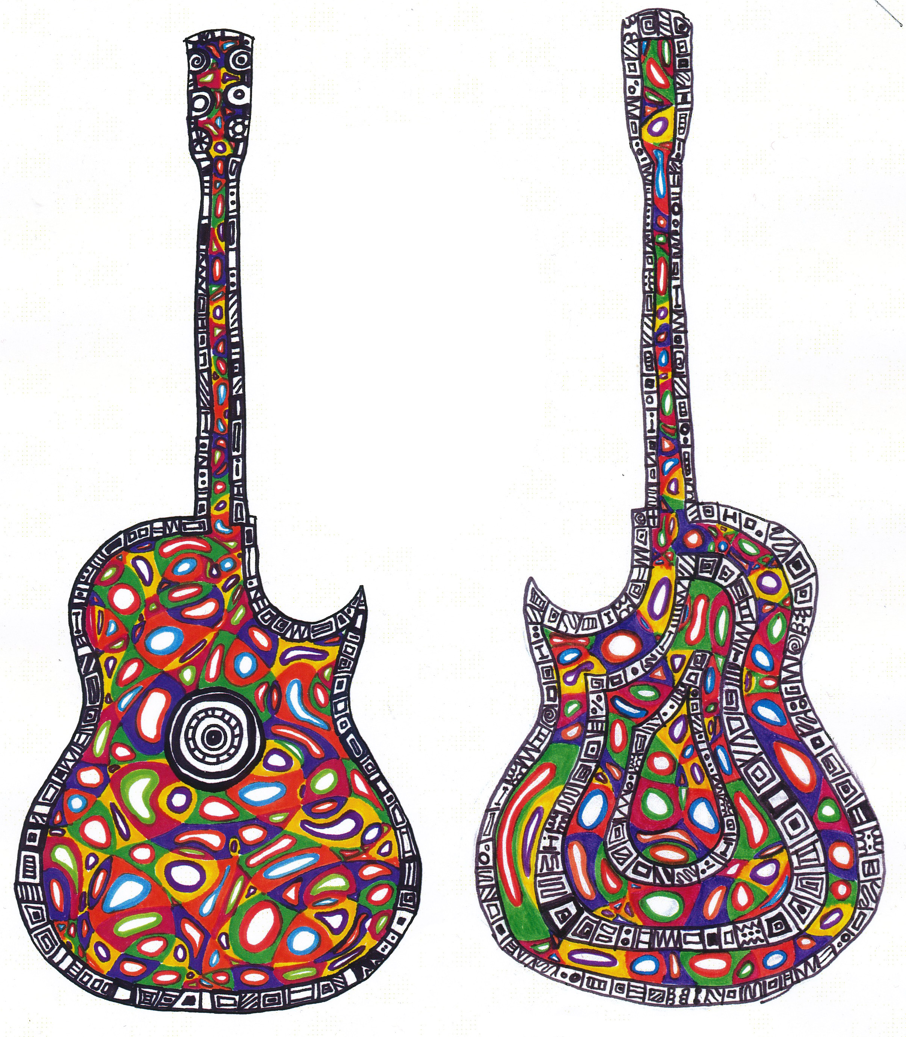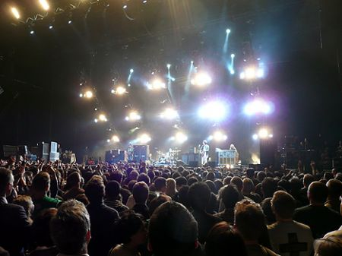

If you are a band or individual that has the ability to stir people, we want you!

To be considered for 2012’s Battle of the Bands Ayuda Concert Event, please provide information listed on the back:

(We also need graphic artists for our 2012 Ayuda artists to be premiered this evening in the lobby as well!) A budding artist desiring publicity? Email inquiries to submit your art at asflitmag@gmail.com):

Band name:

Band Members name and ages:

Contact Information (emails AND phone numbers please)

How would you describe your band – (Style, music, influences).

Would you be available for a weekday audition between 4:00 and 8:00 PM? If so, list the BEST possible days.

ALL candidates will need to submit an electronic sample of their work to:

asflitmag@mail.com before March 13th, 2012. (Audio, utube, video file).

Electronic version of this available at the following places:

http://harrybrake.wordpress.com

http://www.facebook.com/Iciclesnot

